Community Needs Assessment | Final Report
  - December 2018
  - Prepared for Community Action of Ramsey and Washington Counties

Contents
Introduction 3
Overall finding: At the root of poverty is systemic oppression; making systems equitable is the most important community need. 6
Topic finding 1: Housing is a basic need but members of the community struggle to find housing that is affordable for people living low income lives. 9
Topic finding 2: Community members face barriers to employment and need higher paying jobs 10
Topic finding 3: Community members want more educational opportunity but need more support to achieve it. 12
Topic finding 4: Most households in the Ramsey-Washington area have cars, but affordable transportation is still a challenge for many. 13
Topic finding 5: Health and nutrition resources exist in the community, but access is still an issue for many community members. 14
Topic finding 6: The community sees opportunity to make the criminal justice system equitable so that needs for housing and employment are met. 15
The role of Community Action 16
Acknowledgements 18
Reference list 18
Appendix A: Community Profile Report 19
Appendix B: Trends Analysis Report 31
Appendix C: Trends Analysis Interview Protocol 40
Appendix D: Participant Survey Report 43
Appendix E: Participant Survey Protocol 58
Appendix F: Solutions-focused Inventory Report 61
Appendix G: Solutions-focused Inventory Community Focus Group Protocol and Handout 71

Introduction
This needs assessment for Community Action Partnership of Ramsey and Washington Counties was created by gathering stories, experiences, numbers, and statistics from the community. It would not have been possible without the valuable insights and feedback community members and leaders. Findings suggest the community experiences challenges in the areas of housing, employment, health and nutrition, transportation, and systemic structures. At the root of all these challenges is overarching systemic oppression. This concept will be discussed, along with specific findings, throughout this report.
Like all Community Action Partnerships, Community Action Partnership of Ramsey & Washington Counties (Community Action) is required by law to conduct a community needs assessment every three years to ensure strategic planning considers the needs of Community Action’s service area. Community Action partnered with The Improve Group, a St. Paul-based evaluation consulting firm, to conduct the community needs assessment and facilitate the strategic planning process.
This document serves as the final, synthesized community needs assessment report to guide the 2019-21 strategic plan, though Community Action had been learning of results along the way through emerging findings reports at the end of each of the four phases of the needs assessment: describe the community (community profile), understand causes and conditions of poverty (trends analysis), learn more about the lives of Community Action participants (participant survey), and seek community-based input and solutions (solutions-focused inventory).

How information was gathered: Methodology in detail
Different types of data were collected from Community Action’s key partners, community members, Community Action participants, and existing data. All this information informed the current and future needs of the community. Using multiple sources of qualitative and quantitative data ensures the findings best reflect the authentic perspectives of the community. The following describes the specific approach and methods used in each component of the needs assessment.

Community profile
This phase gathered existing data from reputable sources (such as the U.S. Census Bureau and the Minnesota Compass) to describe the demographics of the community, with specific focus on populations living low-income lives. The community profile informed which community partners and populations should be prioritized in the next phases of the needs assessment.
For this needs assessment the community was defined as Community Actions’ service area – Ramsey and Washington Counties. For the community profile, existing data and information such as numbers and percentages were gathered from reliable sources. This information was analyzed by grouping similar categories of information, such as income housing and more. Then, the data was summarized to describe the demographics of the community, with a specific focus on populations living low-income lives. The community profile was developed in July 2018 and used data from the U.S. Census Bureau, state and local agencies, and other researchers. The community profile (as presented in appendix A) was used to inform the trends analysis and solution-focused inventory.

Trends analysis
Representatives from community organizations were interviewed for their perspectives as to the causes of poverty and needs of those living low-income lives in the community. The trends analysis informed which communities to recruit for the solutions-focused inventory focus groups and to decide what input to gather in those upcoming community conversations.
The Improve Group completed 14 semi-structured phone interviews with key informants from August 23 to September 6, 2018. The key informants were representatives of organizations identified by Community Action as partners or potential partners who provide services in Ramsey and/or Washington Counties. Key informants’ areas of expertise ranged from serving specific communities (i.e. Latino, African immigrant, people with a disability, etc.) to offering a variety of direct services (i.e. housing, meeting basic needs, wrap-around services, etc.). Interview data for the trends analysis was analyzed by The Improve Group using a collaborative analysis to group themes and making sense of differences in responses. See appendices B and C for the summary report and interview protocol.
Participant survey
This gathered input from Community Action’s current and past participants to summarize their experiences, barriers, and needs. The participant survey informed which communities to recruit for the solutions-focused inventory and informed the recommendations presented throughout the report. The participant survey also fulfilled the requirement that Community Action collect participant satisfaction data.
The participant survey was administered by Community Action in August and September 2018 with technical assistance and analysis by The Improve Group. The survey was distributed online, in person, and by mail. A representative simple random sample of Community Action service recipients was selected to receive the mail survey. A convenience sampling approach was used for online and in person surveys. A total of 384 people, including 361 people who currently receive services from Community Action, responded to the survey in the survey. Community Action gave The Improve Group raw data from the participant survey. Data was analyzed for frequencies and percentages overall and by subgroups (e.g. by race, household type, etc.) using R Studio. See appendices D and E for the summary report and protocol.
Solution-focused inventory
Community members living low-income lives were invited to participate in focus groups (guided conversations) to react to the information gathered from the Community Profile, trends analysis, and program participant survey to identify possible solutions for Community Action to address poverty. The solutions informed the recommendations presented throughout this report.
The Improve Group completed eight focus groups with community members who were experiencing poverty and living in Ramsey or Washington County. The focus groups were conducted from October 11 to December 12, 2018. The Improve Group recruited and paid Community Liaisons, (individuals who were either members of or have close ties to the selected communities) to lead culturally relevant focus groups and recruit community members for participation. The Improve Group trained Community Liaisons to conduct a focus group and recruit participants, provided them with templates for recruitment (e.g. flyers, social media posts, etc.) that they could adapt the language and messaging to be most relevant to the community being recruited, and provided Community Liaisons with technical assistance and support to throughout the focus group process. Focus group notes for the solution-focused inventory were analyzed using a similar collaborative team approach as done for the trends analysis interviews. The solutions-focused summary is in appendix F and focus group protocol is in appendix E.

Making sense of it all: How analysis was conducted
Once all phases of the needs assessment were completed, The Improve Group reviewed the summary reports from each phase and synthesized the information. This resulted in one overall finding and six findings by topic: housing, employment, health and nutrition, transportation, education, and the criminal justice system. This synthesis included looking for differences and similarities and identifying new connections across all the data sources to draw conclusions about the causes of poverty, the needs of people living low-income lives, and the solutions the community proposes be addressed by Community Action.

Overall finding: At the root of poverty is systemic oppression; making systems equitable is the most important community need.
Systemic oppression is a term to conceptualize the production of inequality through the norms, values, culture, and practices of systems and institutions; it can also be explicit discrimination pursued by the state and its agents (Scott, 2015). In contrast, equity is “the absence of avoidable or remediable differences among groups of people, whether those groups are defined socially, economically, demographically, or geographically” (World Health Organization). With systemic oppression at the root of poverty, equitable systems will help the community overcome poverty.

Systemic racism and other forms of bias were identified as a deeply embedded cause of poverty in the community.
A central finding from the needs assessment is that disparities between the experiences and circumstances of different groups of people, especially racial disparities, are significant in Ramsey and Washington Counties. Throughout the trends analysis, participant survey, and solutions-focused inventory, community members said the causes of poverty are related to systemic racism, oppression, and inequities. This includes but is not limited to unequal access to affordable housing, discriminatory employment and hiring practices, disparities in educational opportunities, and racial bias in policing and the criminal justice system. The data suggest systemic oppression in these foundational areas affect other needs identified in the needs assessment, including access to transportation, nutrition, and healthcare.
According the American Community Survey, people of color are two to four times more likely to be living below the federal poverty level than people who identify as white. In Ramsey County, median household income for residents who identify as white is roughly double who identify as African Americans. While racial disparities are lower in Washington County, median incomes in African American and Hispanic/Latino households are significantly lower than other households in the county. Poverty rates in both counties are approximately twice as high for people with disabilities, and in Ramsey County, poverty rates are significantly higher for foreign-born residents than residents who were born in the United States.
In addition to identifying racial disparities in poverty rates, the trends analysis identified women, aging and elderly residents, and people with disabilities as most likely to experience poverty. Women are often caregivers to family members, such as children or aging parents, and interviewees said caregiving responsibilities are often a significant barrier to having or keeping a job. Elderly residents and people with disabilities have limited opportunities to increase income, which limits their opportunities to keep up with rising costs of living.

Disparities in housing and access to location-based services
Unequal access to safe, affordable housing was a theme throughout all phases of data collection. High housing costs limit people’s choices of where to live, and rental application that require credit checks, background checks, and rental history screenings further limit people’s options. Poor credit history, past evictions, and even criminal history can stay with people for years after the event, making it difficult for people to improve their rental history once they have had a negative event.
Where people live is directly related to the services they can access, especially for people who are burdened by transportation costs or who rely on public transit. Often, the services and resources available to people living low-income lives are located outside of low-income neighborhoods, making it more difficult for people to access the supports they need. This includes support programs for people living low income lives, as well as access to food, healthcare, education, and employment.
Disparities in employment, including racial inequities in pay and hiring practices
Disparities in employment, including racial inequities in pay and hiring practices, were identified in all phases of data collection. According to the Minnesota Department of Employment and Economic Development, overall unemployment rates in Ramsey and Washington Counties were between 3.1 and 3.3 percent in 2017, however statewide unemployment rate show that people of color are far less likely to be employed than people who identify as white. While current unemployment rates are not available by race at the county level, that statewide unemployment rates for people who identify as African American or Hispanic/Latino are more than double those of people who identify as white. According to Minnesota Compass, the unemployment rate for people with disabilities is also significantly higher than for the community overall: nearly 15% in Ramsey County and 7% in Washington County.

Disparities in education, including access to education
Disparities in educational opportunities, school discipline, and the achievement gap were mentioned in the trends analysis, solutions focused inventory, and in the participant survey. According to the American Community Survey, students of color are far less likely than their white classmates to graduate with a high school diploma in four years. This disparity is most notable in St. Paul, where 94 percent of white adults have a high school diploma compared to 80 percent of African Americans, 78 percent of American Indians and about 60 percent of people who identify as Asian, Hispanic or Latino, or who identify with some other race. Throughout Ramsey and Washington Counties, people who identify as white are two to three times more likely to have some post-secondary education than people of color and American Indians. There is a strong relationship between lower educational attainment and poverty. According to the American Community Survey, people without a high school diploma or equivalent are twice as likely to experience poverty than people with at least a high school education.

Disparities in the criminal justice system, including barriers to wealth generation
Having a criminal background is a barrier to employment, housing, and education all of which keep people living in poverty and are a contributing factor to generational poverty. Furthermore, it is well-documented that the criminal justice system disproportionately impacts people of color, especially African Americans and American Indians. In both Ramsey and Washington Counties, the incarceration rate is highest for American Indians, followed by African Americans. Although whites make up the largest demographic in Ramsey County, an analysis of incarceration data conducted by the Vera Institute of Justice found the total number of incarcerations is higher for African American residents than white residents. Locally, according to the Saint Paul Police Department, African American drivers in St. Paul are significantly more likely than other races to be stopped or cited for an equipment violation or an investigative stop, as well as the most likely to be searched on a traffic stop. Incarceration severely limits the opportunities for earning income and paying traffic citations means less money for the household. Given the racial disparities in incarceration and traffic stops, these illustrate systemic oppression in how it prevents wealth generation among people of color.

Addressing systemic oppression is key to ending poverty
The overall finding of this community needs assessment is systemic oppression as the root cause of poverty. Throughout all phases of data collection, community members, service providers, and existing data it was clear that disparities in housing, employment, education, and the criminal justice system are both direct causes and conditions of poverty. While it is important to continue increasing access to affordable housing, well-paying jobs, and quality education, addressing these needs alone is not enough. To eliminate poverty, this root cause must be addressed. The community has many reasons and ways to reduce the symptoms of poverty, however, addressing the root cause—systemic oppression—is a critical community need.
Community members in one focus group discussed that it is obvious to them that systemic oppression is the root cause of poverty in the community. However, their experience when pointing this out to others who are not living low-income lives is being told, “You’re crazy,” “Get up; Get a job,” and “You’re seeing things.” Community members also noted that changing systemic oppression is a big job that requires a large amount of resources to create positive change. But, because they see systemic oppression as the cause of the many barriers they experience in daily life, it is necessary to work to change systemic oppression to address poverty in the community.

Topic finding 1: Housing is a basic need but members of the community struggle to find housing that is affordable for people living low income lives.

The community’s experience with barriers to housing in Ramsey and Washington Counties
High housing costs negatively impact people living low-income lives, as conveyed by all sources of data for this needs assessment. Renters are more likely than homeowners to be housing cost-burdened, which means they are paying 30% or more of their income toward housing costs. According to analysis from the Minnesota Housing Partnership, one-quarter of Washington County’s 89,898 households and one-third of Ramsey County’s 206,156 households are cost-burdened. Over half of Community Action participant survey respondents reported being housing cost burdened and one quarter of respondents use more than 50% of their income on housing. Focus group participants were not surprised by this finding; many reported spending more than 30% of their income on housing. They shared that when so much of their income goes to pay for housing, there is often not enough money remaining to pay for other, even the most basic, needs.
People living low-income lives also experience many other systemic and individual barriers in finding and securing housing. Frequently, people living low-income lives do not feel welcome or wanted in communities, as found in the trends analysis and solutions-focused inventory. Community members at the focus groups said having a criminal history and completing background checks can be barriers to finding safe and affordable housing. Focus group and survey participants also said landlords often use housing screening and selection criteria that is based on criminal background checks and/or credit scores. In many cases, landlords will deny housing applicants for past evictions and criminal convictions that are decades old. Community members at focus groups said credit checks can prevent families from renting or owning properties, and that credit histories can be a large barrier even when a family can currently meet their financial obligations.
These barriers significantly reduce the number of housing options for people with low credit scores, criminal histories, and past evictions. Having few housing options means people living low-income lives feel they need to put up with “slum lords” and substandard conditions because they cannot secure housing anywhere else. Finally, focus group and survey participants said that restrictions, waiting lists, and finding a landlord who will accept Section 8 vouchers are barriers to securing higher quality and affordable housing through the Section 8 program.
Interviewees and survey respondents shared that people living low-income lives also face barriers to homeownership. Specifically, there are few services or programs available to support low-income households in becoming homeowners and even fewer services that support these households with the ongoing needs of homeownership, such as maintenance costs.

Housing needs of community members
A critical need in the community is affordable housing, as evidenced by all data sources for this needs assessment. The community needs housing to be of higher quality, including responsive landlords, so people living low-income lives have healthy and safe housing.
Additionally, interviewees see integrated housing as a need in the community. They shared that communities thrive where people feel welcome and supported, there is decreased stigma on affordable housing and poverty, and people have greater access to resources. Interviewees also pointed out the need for programs that support low-income households in becoming and remaining homeowners.
Finally, focus group participants discussed that the community needs more equitable approaches to securing housing. They specifically pointed to addressing current barriers in rental housing selection criteria (e.g. credit checks, background checks, and prior evictions). Focus group participants also expressed a need for more housing which accepts vouchers or renters using public assistance.

Topic finding 2: Community members face barriers to employment and need higher paying jobs

The community’s experience with barriers to employment
While there are many jobs available in the community, most jobs that people currently living low-income lives can secure are jobs that do not pay a living wage, do not include benefits, and/or have inconsistent schedules, as evidenced by the Trends Analysis and Solutions-Focused Inventory. Low overall unemployment rates mask employment disparities. According to American Community Survey, unemployment rates are significantly higher for people of color (two to three times higher), people without a high school diploma, as well as for people with disabilities (five times higher) and elderly residents than the community overall.
Many of the available jobs do not pay wages that cover the basic costs of living. Some participants in the trends analysis and solutions-focused inventory explained that many people who can find work cannot afford childcare or transportation costs. Others may run into situations where they make just enough to lose benefits, such as SNAP, but not enough that they can afford their necessities without this support. Benefits such as health insurance buffer families and individuals from poverty, but low wage jobs rarely have employer-paid benefits. Community members in one focus group shared that they were happy to be working full-time and off County benefits for the first time in several years; however, after taxes, health insurance, and other items were deducted from their paycheck, more money is taken out of their paycheck than what they take home. Participants talked in depth about how County and other services dis-incentivizes people to work full-time because when they work low-paying full-time jobs they have fewer resources than when they work less and receive County benefits and services. There is not a gateway for them to work full-time jobs that pay a living wage.
Low-income members of the community may struggle to find the supports they need to get and keep employment. The available jobs do not have the flexibility people need to balance their work, home, and family responsibilities. This is particularly true for women and other individuals with caregiving responsibilities. Caregiving was one of the most common barriers to employment mentioned in the participant survey. Mental health, health concerns, and disabilities are also barriers to employment, either because the person cannot work or because they cannot find work. Survey participants shared that the community needs to provide more accommodations to ensure people with disabilities can successfully find and keep jobs.
Both wages and job attainment are often strongly influenced by systemic and racial oppression. Participants in the solutions-focused inventory and the survey said people of color and immigrants often receive lower wages than white workers for the same, or very similar, work. They also shared that, while opportunities for promotion are rare in many jobs without high experience or educational requirements, they are especially rare for people of color. Community members at the focus groups described how people of color have more trouble finding jobs that their white peers. They were especially worried about pay gaps for people of color, describing how they often do the same exact work as white coworkers while receiving significantly less pay. Participants in the solutions-focused inventory and survey also shared that hiring practices, such as background and credit checks, can be barriers to employment, preventing people from getting jobs which they are otherwise qualified for.
In the trends analysis, participant survey, and solutions-focused inventory, respondents explained that there is a lack of jobs available that match people’s skills, abilities, or interests. In addition, Karen focus group participants said recent immigrants have a hard time finding jobs that match their skills because their qualifications are not recognized by employers. This is a systemic problem, as many employers will not recognize previous education or experience for this community.

Employment needs of community members
All the sources of data used in the needs assessment led to the same findings related to employment. One of the most pressing needs is the need for jobs that pay a living wage. Such jobs are essential for community members to not just survive but to get out of poverty. Additionally, the community shared a need for fair hiring practices, including fighting racial discrimination and removing barriers based on credit and background checks.
As complement to this need, the community needs more job training. The solutions-focused inventory showed need for more training in skilled trades, while the trends analysis expressed a need for soft skills training to be better at finding and applying for jobs.

Topic finding 3: Community members want more educational opportunity but need more support to achieve it.

The community’s experience with barriers to education
Overall, residents in the Twin Cities metropolitan area generally have high levels of educational attainment, yet significant disparities between groups of people exist. The American Community Survey shows that people without a high school diploma experience poverty approximately twice as much as people with a diploma. This disparity is also present among people who received services from Community Action. For example, one in five of survey respondents said no one in their household has received a high school diploma (21%). However, only six percent of people who identified as white said no adult in their household has received a high school diploma or equivalent, compared to 19 percent of people who identified as Hispanic/Latino, 20 percent of people who identified as Black/African-American, and 42 percent of people who identify as Asian. Furthermore, the average household income for survey respondents was $26,089, which is only $989 above the Federal Poverty Level for a family of four. Overall, 72 percent of survey respondents said they live in households with incomes at or below the federal poverty level.
Higher levels of education are closely tied to greater income, however, there are often barriers to pursuing further education. Participants in the survey, trends analysis, and solutions-focused inventory shared that, while low-income people want more education, they often find it difficult to access. The costs of education are a primary barrier for many. Finding transportation to classes and arranging for childcare are also challenges for many members of the community, especially considering the high costs associated with them. Community members participating in focus groups highlighted a unique need for adults with children to access and complete higher education. They said that parents need to juggle working, finding childcare, attending classes, doing homework, and travel time when they attend college.
The survey, trends analysis, and solutions-focused inventory also emphasized that structural inequities can be a barrier to education. American Community Survey data shows significant racial disparities in educational attainment, and the community members who participated in data collection shared that lack of access to educational opportunities is a significant challenge for them. The trends analysis also emphasized that racial disparities in school discipline can have a large impact on students and their educational attainment.

Education needs in the community
Members of the community have a strong desire for further education. During the solutions-focused inventory, some groups shared that they saw education as the community’s primary need. Participants in the survey and focus groups shared that preparation and support in attending traditional colleges would be extremely helpful in building skills and wealth. These sources also suggested that English classes are needed in their communities and could help them find jobs and navigate systems better. Participants in the solutions-focused inventory also saw a need for education and training in technical job skills which could prepare them for well-paying jobs. The community also shared a desire for more teachers of color and culturally appropriate education through the participant survey.
Overall, the community needs assessment found the community has clear needs related to adult education. However, this does not mean that early childhood education and quality K-12 education are not important for the community. According to the participant survey, 25 percent of respondents with children under age five need support services to prepare their children for school and 25 percent of respondents with children under 18 said they need after school or summer programing for their children.

Topic finding 4: Most households in the Ramsey-Washington area have cars, but affordable transportation is still a challenge for many.

The community’s experience with barriers to transportation
Although most families in the community report having vehicles, the cost of owning and operating a car is often a significant burden for low-income households. Data from the Minnesota Compass suggests that the median family in the community spends around 20% of their income on transportation which leaves less room to cover the cost of other basic needs such as housing, food, utilities, clothing, healthcare or childcare. Despite this substantial cost-burden, many low-income families in the area choose to own a vehicle because they see it as the only reliable way for them to get to work or access other services for their families.
Participants in the solutions-focused inventory also shared that they may avoid paying for car insurance or needed car repairs because they are not affordable. Additionally, they shared that fees for minor traffic or parking tickets can be a burden on a limited income. Additionally, survey participants shared that some community members face barriers to getting driver’s licenses because of language barriers and immigration status.
Participants in the survey, trends analysis, and solutions-focused inventory also shared that access to public transportation is significant challenge. This is reinforced by data from Minnesota Compass which shows that only 14 percent of jobs in Ramsey County and two percent of jobs in Washington County are considered accessible by public transit. Transit schedules and routes often do not match community members’ needs, especially for residents of Washington County. Long commute times by public transit compound this issue, especially for those travelling to or from the suburbs. Participants in the solutions-focused inventory explained that although there are more job opportunities in the suburbs, the combination of these issues means that community members must have cars to access them even if those cars are a significant financial burden to their limited budgets. This difficulty of access to public transit is compounded by a lack of door-to-door transportation for people with disabilities and the elderly. Participants in the survey and trends analysis shared that although door-to-door services exist in the area, they are inadequate to the need and often unreliable.

Transportation needs in the community
Through the survey, trends analysis, and solutions-focused inventory, the community expressed that affordable and accessible public transportation is a significant need. This includes lower costs, more routes and service times, and more door-to-door support for community members who need it. Survey and focus group participants emphasized that more routes and service times are greater needs in Washington County, where current routes are very limited. If public transit were improved there would be more transportation options for low-income people to more easily get to their jobs, school, and child care.
Participants in all data collection methods shared that the community needs much more support in meeting the costs of owning/operating a car including support for car repairs.

Topic finding 5: Health and nutrition resources exist in the community, but access is still an issue for many community members.

The community’s experience with barriers to nutrition and healthcare access in the community
Many members of the community struggle to access food support and meet their nutrition needs. Participants in the solutions-focused inventory, trends analysis, and participant survey shared that there are many barriers to accessing food support such as SNAP or WIC, including the need to reapply often, submit multiple applications, and use different systems in different counties. These supports may not provide adequate nutrition for all who use them, and as a result, many families use food shelves to supplement their nutrition needs. However, food shelves may have residential or other requirements that limit access for community members. Additionally, many families struggle to find culturally appropriate foods, which, they said, are often inaccessible through SNAP or food shelves. Other barriers to healthy and culturally appropriate foods include cost and the location of stores, making them harder to access. Approximately 25 percent of respondents to the participant survey report regularly running out of food before the end of the month.
The cost of, and access to, healthcare is also a challenge for many members of the community. Participants in the solutions-focused inventory named access to healthcare as one of their major concerns. This finding aligns with issues raised around employment, namely that many low-income people do not have jobs that include employer-paid health benefits. Notably they also reported that access to care is made difficult because it is a struggle to understand and navigate the healthcare system and insurance policies and procedures. Additionally, participants discussed the cost of healthcare as being a significant financial burden. They said that if they do not qualify for Medical Assistance there is not an affordable option available to them. Data from Metro SHAPE and the participant survey also found that access to care can be a challenge due to lack of availability and that many members of the community may skip or delay medical care or medications because of high out-of-pocket costs even if they have basic insurance.

Health and nutrition needs of community members
In the participant survey, trends analysis, and solutions-focused inventory, community members shared that they need more access to and education around health and nutrition. Specifically, survey and solutions-focused inventory participants expressed a need for more education around healthy eating and better access to affordable, healthy food. They shared that more knowledge about healthy choices would help them make better, more nutritious decisions around what they eat. They also expressed a desire for better access to culturally appropriate foods which, like healthy foods, are often difficult to find due to both cost and location of stores. Streamlined food support systems were named as something which could help with this in both the survey and solutions-focused inventory.
Furthermore, through the solutions-focused inventory, the community expressed a need for more education about healthcare systems and policies which could help them navigate and make more informed decisions about their health and medical care. Participants in the solutions-focused inventory also shared a need for more affordable healthcare for all, especially for people who do not have employer-paid benefits, while participants in the survey emphasized a need for more quality, affordable dental care.

Topic finding 6: The community sees opportunity to make the criminal justice system equitable so that needs for housing and employment are met.

The community’s experience with inequity in systems
Many systems in our community, such as criminal justice systems, show racial disparities. Those interviewed in the trends analysis identified significant racial bias in policing and incarceration, and participants in the solutions-focused inventory identified a lack of equity and community connections in policing. The community profile illustrates this through disproportionally high incarceration rates for residents of color as compared to white residents. Likewise, the community profile shows that this true in situations involving the most minor offenses in which people of color are more likely to be stopped and cited.
These disparities in justice systems have deep impacts on the community. Participants in the survey, trends analysis, and solutions-focused inventory shared that incarceration and criminal records can change a person’s life not only by taking them away from their families but also denying them opportunity to change and improve their future circumstances. This is especially the case when individuals are denied employment or housing based on criminal background checks.

Equity in systems needs of the community
There is an overall need in the community for more equity in policing practices so that all people receive the same treatment under the law. The trends analysis and solutions-focused inventory both emphasize that equity in policing will give low-income community members greater opportunities to improve their life circumstances. Participants in the solutions-focused inventory suggested that law enforcement professionals who relate to and are embedded in the community could be one way to improve these systems. In addition to adopting fairer policing practices, community members suggest that landlords and employers place less emphasis on, or even stop using criminal background checks during their screening processes for employees and tenants.

The role of Community Action
Focus group and interview participants identified several opportunities for Community Action to extend and deepen its work in Ramsey and Washington Counties. Community members encourage Community Action to continue to view people living low-income lives as community assets. They explained that their diversity, knowledge, and deep understanding of the community are valuable in understanding the needs and barriers community members experience in daily life. Participants suggest that Community Action can partner with community members and various community groups to help the community overcome poverty. Community members in one group encouraged Community Action to create a committee of community members to guide Community Action through the findings of this needs assessment. They said this committee of community members could help Community Action understand what the findings mean to people living in the community and how Community Action can best take actionable steps to address the findings.
The community is rich in services and resources, especially in Ramsey County and the City of St. Paul; however, focus group participants explained that often people in the community are often not aware of services available or there are barriers to accessing services that are present. Therefore, community members suggest Community Action step into a role of communicating and coordinating services and resources for people living low-income lives. Community Action could act as a coordinator to ensure people living low-income lives are aware of and have more equitable access to community resources.
Focus group participants also encouraged Community Action to play a larger advocacy role in the community to work toward policy and systems changes that will help the community overcome challenges. Specific examples of advocacy work suggested were: Community Action participating in political meetings at all levels of government, working to influence and support legislation, and supporting community members in advocating for policy change. Focus group participants also encouraged Community Action to be active in local community initiatives by participating in existing community groups.
Given that one of Community Action’s commitments is to educate the public on issues that affect people living low-income lives in our community, focus group participants offered several ideas for how Community Action could approach this. They explained that it is important for the public to understand that there is nothing shameful about living in poverty and people living low-income lives are proud of themselves and their lives. Participants also encouraged Community Action to address myths associated with poverty and to be direct about daily life and the barriers people living low-income lives experience. Participants also asserted that being vocal about problems and barriers in the community is a way to work to get them addressed. Their comments suggest that an initial step in addressing the root causes of poverty is to talk about and contextualize it in systemic realities. Community Action could do this in collaboration with organizations that have experience in this area and leverage the strengths those organizations have developed over time.
Participants in the solutions-focused inventory and trends analysis identified that low-income people are an underutilized community asset capable of driving these efforts. This suggest that community members who are experiencing low-income lives should lead and/or inform the work of developing solutions to the causes and conditions of poverty.
Participants in key informant interviews also had suggestions for how Community Action can be most effective in the community. Several interview participants shared that they or the communities their organization serves are not familiar with Community Action and the range of services Community Action offers. They encourage Community Action to increase its visibility and presence in the community. Additionally, interview participants suggested Community Action develop strategic partnerships with community organizations that already work in the areas that have been identified as needs to overcome poverty. Specific partnership suggestions include organizations that work in housing, transportation, and economic development. Better coordination among organization is also important so that the community can address the symptoms of the problem and the root causes to prevent the problem altogether.

Acknowledgements
This needs assessment would not be possible without the time and dedication from several individuals and organizations. We would like to acknowledge:
Community Liaisons: |  | Trends Analysis interviewees:
Brenda Bolar | The Salvation Army | Nancy Brady | Neighborhood House
Cesar Orjuela | CLUES | Nicole Braun | CLUES
Shereen Page | Community Action board member | Trisha Cummins Kauffman | Solid Ground
Erin Pavlica | Community member | Ted Flaum | Jewish Family Services
Vic Rosenthal | Vic Rosenthal, LLC | Gene Gelgelu | African Economic Development Solutions
Pae Say | Neighborhood House | Makeisha Hall | Model Cities
 |  | Mary Sue Hansen | Suburban Ramsey Family Collaborative
 |  | Carla Kohler | CLUES
 |  | Tracy Maki | Valley Outreach
 |  | Jenny Mason | Community Resource Center of St. Andrew’s
 |  | Renada Rutmanis | Hubbs Center for Lifelong Learning
 |  | Dawn Simonson | Metropolitan Ara Agency on Aging
 |  | Boa Vang | Hmong American Partnership
 |  | Joan Willshire | MN Council on Disability
 |  | Eva Wood | Outfront Minnesota
The Improve Group and Community Action would also like to thank the more than 50 community members who participated in focus groups and the nearly 400 people who completed the participant survey.

Reference list
Scott, J. (2015). Institutional racism. In A Dictionary of Sociology (4th edition). Oxford University Press.
World Health Organization. Health systems topics. Retrieved from https://www.who.int/healthsystems/topics/equity/en/.

Appendix A: Community Profile Report
This community profile informs the needs assessment for Community Action of Ramsey and Washington Counties. It describes the demographics of the community, with specific focus on populations living low-income lives. This community profile was prepared by The Improve Group in July 2018 using data from the U.S. Census Bureau, state and local agencies, and other researchers. While the ultimate purpose of this community profile is to contextualize the final needs assessment, it also informs which community partners and populations should be prioritized in the next phases of the assessment (the Trends Analysis and Solutions-Focused Inventory).

The population of Ramsey and Washington Counties has grown over 10% since 2000, with most of the population growth in Washington County.
Totaling 780,373 people, the population size in Ramsey and Washington Counties is 531,528 and 248,745, respectively. In the last 18 years population in Washington grew 24% whereas Ramsey experienced 4% growth. Regardless of the size difference in population growth, both counties have seen increases in their populations of color, especially Asian residents, while Ramsey has also seen a decline of approximately 30,000 residents in white population and Washington’s white population has stayed steady. The counties’ population of foreign-born residents has also expanded over time, approximately doubling since 2000. Currently, 19% of Saint Paul, 16% of Ramsey and 7% of Washington residents are foreign born. The primary birth country of immigrants in Minnesota is Mexico, although the state is also home to many Hmong, Indian, and Somali migrants.
Demographics of Ramsey and Washington Counties |  | Saint Paul | Ramsey County | Washington County
 | Age (median) | 31 | 35 | 38
Sex | Male | 49% | 49% | 50%
 | Female | 51% | 52% | 51%
Race | White | 60% | 70% | 88%
 | Black or African American | 16% | 11% | 7%
 | American Indian and Alaska Native | 1% | 1% | 1%
 | Asian | 15% | 12% | 5%
 | Some other race | 4% | 3% | 1%
 | Two or more races | 4% | 4% | 2%
Ethnicity | Hispanic or Latino origin | 10% | 7% | 3%
Approximately 12% of Ramsey County’s population has one or more disability, while in Washington County this demographic makes up approximately 9% of the population. This census measure of disability likely underestimates the true count of people with disabilities given the complexity of the topic and difficulty of measuring it.

Income inequality in the Twin Cities metro is increasing; median incomes do not match the cost of living.
Income inequality in the Twin Cities metro area had the second fastest growth rate in 2000-2015 when compared to 11 other metro areas and shows signs of increasing. This means the earnings gap between the upper and lower quartiles of income is continuing to grow. While people in higher income houses are seeing their earnings rise, wage growth in low income housing is not keeping up with inflation. This leaves many households unable to pay for basic costs of living.
For all households, the median household income is $57,717 in Ramsey County and $86,689 in Washington County. These numbers are very different for renters; median household income for renters in Ramsey County is $31,693 in and those in Washington County earn $43,539 annually. Racial disparities also exist, especially in Ramsey County where the median household income for residents who identify as white is roughly double who identify as African Americans. While racial disparities are lower in Washington County, median incomes in African American and Hispanic/Latino households are significantly lower than other households in the county.
Median Household Income by Race and Ethnicity | Saint Paul | Ramsey County | Washington County
All households | $50,820 | $57,717 | $86,689
White | $60,771 | $64,784 | $86,767
African American | $26,373 | $29,396 | $64,917
American Indian | $35,653 | $39,667 | $88,125
Asian | $40,056 | $48,654 | $102,730
Some other race | $37,897 | $39,095 | $85,192
Two or more races | $37,194 | $40,689 | $81,700
Hispanic or Latino origin (of any race) | $37,853 | $39,256 | $69,700
Additionally, there is a significant earning gap in the Ramsey County, as people are unable to meet their needs with the median income. The average cost of living for a household in the Twin Cities metro region is over $61,000, which is higher than Ramsey County’s median household income and more than double the median income for African American households. In Washington County, median household income for all races is higher than the cost of living. However, there are still many people in the county who are struggling to pay their household expenses. Average cost of living includes costs such as food, housing, and childcare, and transportation.
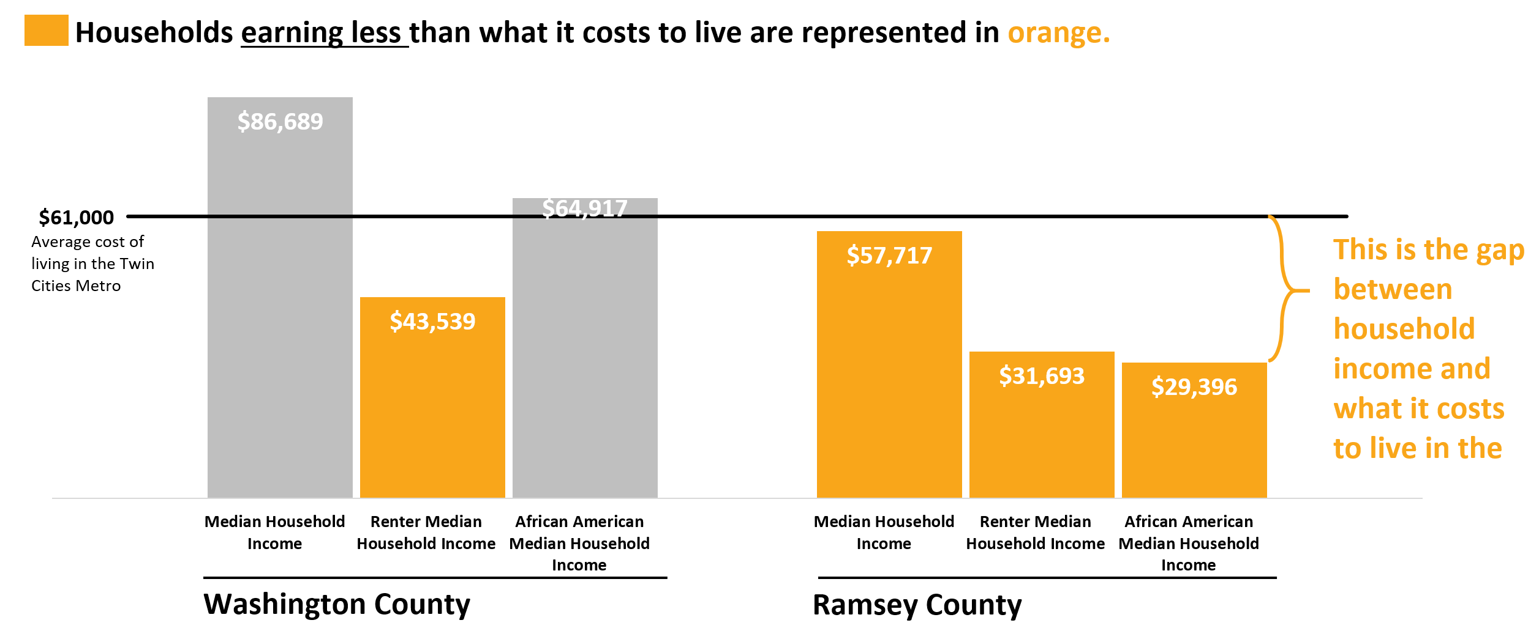
For some households in Ramsey and Washington Counties, incomes may be supplemented with public assistance, Supplemental Nutrition Assistance Program (SNAP), or Supplemental Security Income (SSI). Nearly one in five Saint Paul residents receives SNAP benefits. The use of these programs is as follows:
Public assistance program use | St. Paul | Ramsey County | Washington County
SNAP | 19% | 13% | 5%
Cash public assistance income | 7% | 6% | 2%
Supplemental Security Income | 7% | 6% | 3%
High costs of childcare are a significant burden. The average weekly cost of childcare ranges from $340 for infants and $208 for school-age children, or approximately 24% of the median household income in Ramsey County and 16% of Washington County median household income.
Low income households with children under age six may be eligible for the Child Care Assistance Program and the Special Supplemental Program for Women, Infants, and Children (WIC). Approximately 13% of eligible Ramsey County children and 11% of eligible Washington County children are served by the Child Care Assistance Program. WIC serves the majority of low income children under age six in Ramsey and Washington Counties (82% and 57%, respectively).
Additionally, many families turn to Free and Reduced Lunch programs for support. Although numbers of children using this program are not available, 58% of children in Ramsey County and 21% of children in Washington County are eligible to participate. This indicates families’ high need for financial assistance within Ramsey and Washington Counties.

Poverty is geographically concentrated in St. Paul, with higher rates among populations of color and people who report one or more disabilities.
In 2018, the federal poverty level (FPL) was set at $25,100 in annual income for a family of four. This profile focuses on low income households in Ramsey and Washington Counties, which includes households with incomes at or below 200% FPL. This definition encompasses everyone who is or could be served by Community Action.
Community Action’s definition of low income includes people who are unable to meet their needs with their incomes, even if their income is above the federal poverty line. In our community, 34% Ramsey County residents and 15% of Washington County residents are considered low income by this definition. In Saint Paul, 42% of the population is considered low income. The following map shows the geographic distribution of residents in Ramsey and Washington Counties who are living in households with incomes at or below 200% FPL.
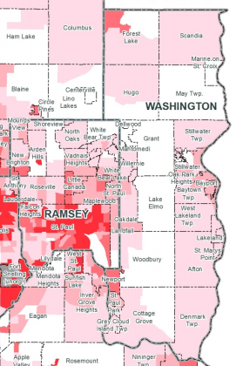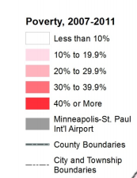
While this profile focuses on people with household incomes at or below 200% of the FPL, attention should be paid to people who are currently experiencing extreme poverty, including households with incomes at or below 125% and 100% of the FPL. In Ramsey County, 21% of the population is living at or below 125% FPL and 16% are living at or below 100% FPL. In Washington County, these rates are 7% and 5%, respectively. Poverty rates in both counties are approximately twice as high for people with disabilities, and in Ramsey County, poverty rates are significantly higher for foreign-born residents than residents who were born in the United States.
The following table shows a demographic breakdown of the population at or below 100% of the FPL as this data shows which residents are currently experiencing extreme poverty:
Individuals with incomes at or below 100% of the federal poverty level by demographic groups |  | Saint Paul | Ramsey County | Washington County
Age | Under 18 | 31% | 24% | 6%
 | 18-64 | 20% | 15% | 5%
 | 65 and over | 12% | 8% | 4%
Sex | Male | 21% | 15% | 4%
 | Female | 23% | 17% | 6%
Race | White | 12% | 9% | 5%
 | Black or African American | 40% | 36% | 14%
 | American Indian and Alaska Native | 39% | 36% | 5%
 | Asian | 33% | 29% | 3%
 | Native Hawaiian and Other Pacific Islander | 22% | 18% | --
 | Some other race | 26% | 25% | 9%
 | Two or more races | 31% | 26% | 13%
Ethnicity | Hispanic or Latino origin (any race) | 28% | 25% | 14%
Households | All households | -- | 14% | 5%
 | All families | 16% | 11% | 4%
 | Married couple families | 8% | 5% | 1%
 | Families with female householder | 38% | 31% | 17%
Although not represented in this table, it is important to note that children of color have especially high rates of poverty. For example, Native American and African American children experience poverty three to four times the rate of white children in Ramsey and Washington Counties. Overall, the geographic concentrations of poverty are also areas where the population is predominantly people of color. However, the geographic distribution of poverty may hide some of the realities for low income people in Washington County. Because Washington County is relatively wealthy, it does not have the same localized concentrations of poverty as Ramsey County.

The number of cost-burdened households are rising in Ramsey and Washington Counties; renters are far more likely to be spending too much of their income on housing costs.
Cost-burdened households are those paying 30% or more of their income toward housing costs. One-quarter of Washington County’s 89,898 households and one-third of Ramsey County’s 206,156 households are cost-burdened., In both counties, renters are far more likely to be housing cost burdened than households who own their homes.
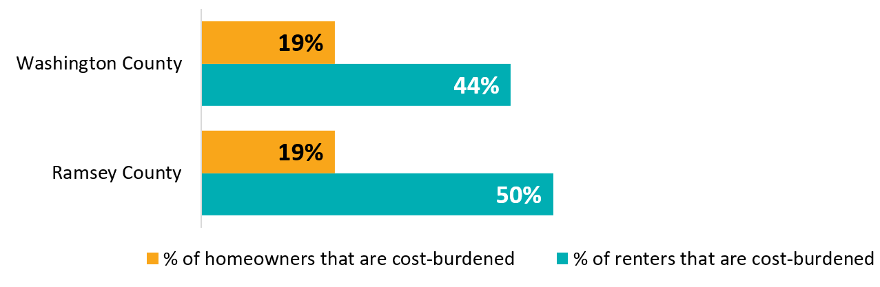
Incomes for both renters and homeowners have fallen over time, while rent and home values rise. Given the low median incomes of renters, these costs can present a significant burden. While the median renter can afford $792 in Ramsey County and $1,088 in Washington County, median rents are $865 and $1,144. This cost-burden in especially great for those households which need multiple bedrooms. Fair market rent for two-bedroom apartments in Ramsey and Washington Counties is far higher than what the median renter can afford. Minnesota Housing Partnership estimates that in both counties, a minimum wage worker must work 75 hours per week to rent a two-bedroom apartment.
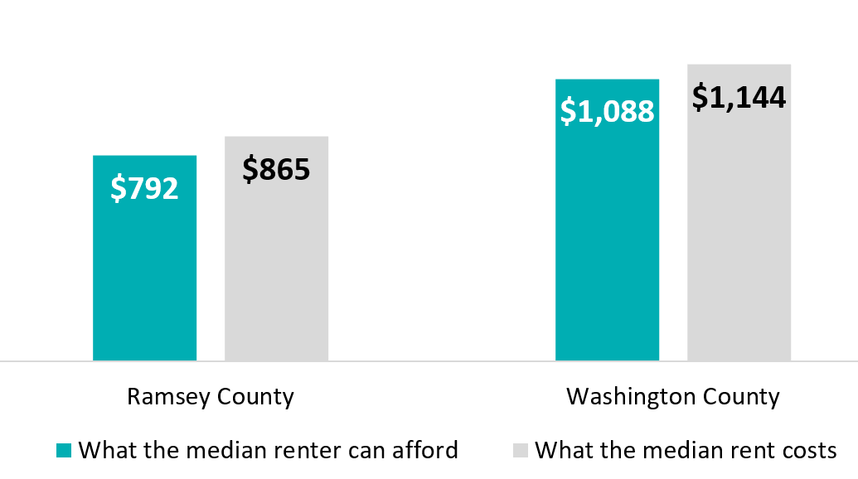
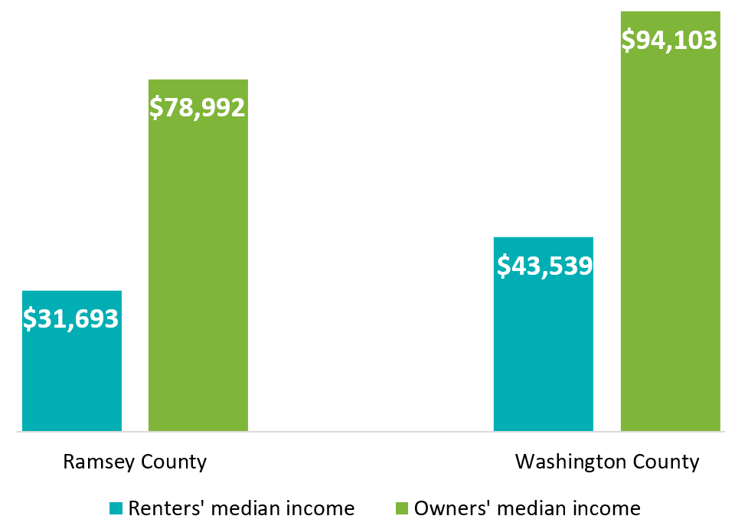
Renters are much more likely to be experiencing poverty than homeowners. In St. Paul, 4% of homeowners have incomes at or below 100% FPL, compared to 35% of renters a disparity echoed across the rest of Ramsey and Washington Counties.
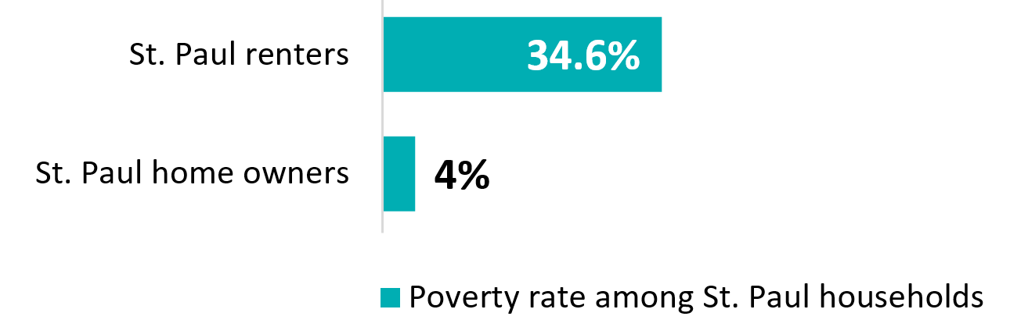
In addition to the above factors there are certain conditions of occupied housing which classify it as “substandard,” such as a lack of plumbing or kitchen facilities. Across Ramsey and Washington Counties, 30% of occupied housing has one or more substandard condition.
The high cost of housing is compounded by extremely low housing vacancy rates. Home vacancy rates in both Ramsey and Washington Counties are below 5%, while rental vacancies are even lower: 3.6% in Ramsey County and 1.7% in Washington County.

Unemployment is low in Ramsey and Washington Counties but is disproportionately higher in marginalized communities.
The 2017 unemployment rate in Ramsey County was 3.3% and 3.1% in Washington County. The unemployment rate is significantly higher for people of color, especially African Americans and people of Hispanic or Latino origin. As of June 2018, statewide unemployment rate among people who identify as Black is 5.6% and 5.3% among people who identify has Hispanic/Latino while unemployment for people who identify as white is 2.6%. The unemployment rate for people with disabilities is also higher than average: nearly 15% in Ramsey County and 7% in Washington County.
Underemployment also presents problems in Ramsey and Washington Counties. This measure encompasses people who are employed part-time but want full-time work. Although data is not available at the county level, DEED estimates that underemployment rates in Minnesota were 7.5% in 2017.
Throughout Minnesota, job vacancies outnumber unemployed workers; however, this may vary within Ramsey and Washington Counties. The high cost of transportation and low number of jobs accessible by public transit may present barriers to accessing jobs. Most vacant jobs require less than a year of experience and require a high school degree or less. Significantly, the median wage offered by currently vacant positions is below the cost of living in Ramsey and Washington Counties.

There are racial disparities in education levels.
In Minnesota, nearly 93% of adults have a high school diploma and 34% have a bachelor’s degree or higher. Ramsey and Washington Counties have similar rates of educational obtainment; however overall educational attainment rates hide significant racial disparities. For example, 80% of African American adults in Saint Paul have completed high school compared to 94% of white adults in the same city.
Disparities in educational attainment continue to widen with post-secondary education. While 42%-46% of white residents in Ramsey and Washington Counties have a bachelor’s degree or higher, only 19% of Ramsey County residents who identify as African American have a college degree. There is a larger disparity for American Indians, with only 14% of Ramsey County and 19% of Washington County American Indian adults reporting a bachelor’s degree or higher.
High school graduation rates by race and ethnicity | Saint Paul | Ramsey County | Washington County
White | 94% | 95% | 97%
African American | 80% | 82% | 89%
American Indian | 78% | 81% | 85%
Asian | 62% | 69% | 87%
Native Hawaiian | 62% | 80% | 100%
Some other race | 58% | 61% | 78%
Two or more races | 86% | 89% | 96%
Hispanic or Latino origin | 63% | 66% | 85%

Post-secondary education attainment by race and ethnicity | Saint Paul | Ramsey County | Washington County
White | 50% | 46% | 42%
African American | 16% | 19% | 39%
American Indian | 13% | 19% | 14%
Asian | 21% | 31% | 57%
Native Hawaiian | 36% | 17% | 64%
Some other race | 9% | 11% | 17%
Two or more races | 32% | 32% | 39%
Hispanic or Latino origin (of any race) | 18% | 20% | 28%
In general, people with higher levels of educational attainment report higher income levels. For example, Washington County adults without a high school diploma report living in poverty at more than twice the rate of people with a high school diploma (36% and 14%, respectively). Poverty rates are low among adults with a bachelor’s degree or more, ranging from four percent in Ramsey County to two percent in Washington County. Among adults younger than 65, females are more likely hold a post-secondary degree compared to males in both counties; however, African American males in Ramsey County and Asian men in Ramsey and Washington Counties are more likely to hold a post-secondary degree than females of the same race.

Most families report access to vehicles, yet costs of transportation are high.
While most Ramsey and Washington County households report owning at least one vehicle (89% and 97%, respectively), the costs of owning and operating a vehicle are a significant burden in low income households. Minnesota Compass estimates that the median family in Washington County spends 21% of their income on transportation, while residents of Ramsey County spend 18% of their income here. Driving is reported as the primary mode of transportation (83% in Ramsey County and 90% in Washington County), However, the number of people in the Twin Cities metro who have driver’s licenses and registered vehicles is declining,
Many residents – especially those with low incomes – likely rely on public transit rather than driving. Approximately 6% of Ramsey County adults and 3% of Washington County adults use public transit to commute to work. While the community has public transportation systems, only 14% of jobs in Ramsey County and 2% in Washington County are reachable within 30 minutes by public transit or walking, presenting a significant barrier to people who rely on public transit. In both counties the average travel time to work is approximately 25 minutes.

Access to health care presents a challenge for many Ramsey-Washington residents.
People who cannot afford health care costs may delay care or forgo it altogether. Of people who needed health care, 18% of Ramsey County adults and 16% of Washington County adults have delayed or skipped health care because of costs. The percent of people in Ramsey and Washington Counties who do not have health insurance uninsured people is low (5% and 3%, respectively). However, 22% of Ramsey County residents and 18% of Washington County residents struggle to pay for health insurance, and many have delayed or skipped physical and mental health care because of costs.
When people do not have enough money to pay for the basic costs of living, they may not be able to pay for food and medical care they need to stay healthy. This, combined with higher levels of stress, can lead to poor health outcomes. People experiencing poverty are less likely to meet recommended standards of exercise and healthy eating, as well as being more likely to have frequent poor mental health days than people who are not living low income lives. This may be compounded by factors such as food insecurity: 23% of Ramsey County residents and 5% of Washington County residents have worried that food would run out before they could afford to buy more.

Traffic stops and incarceration rates show racial disparities.
The serious crime rate per 100,000 residents is 3,489 in Ramsey County and 2,113 for Washington County. This includes the rate of eight serious types of crime included in the FBI’s annual crime index.
Traffic stop data, although not available on a county level, is publicly posted for Saint Paul. This shows that while moving violations are the most common reason for stops across demographics, African American drivers are significantly more likely than other races to be stopped or cited for an equipment violation or an investigative stop, as well as the most likely to be searched on a traffic stop.
Incarceration rates in Ramsey and Washington Counties are both below national levels. In both counties, the incarceration rate is highest for Native Americans, followed by African Americans. Although whites make up the largest demographic in Ramsey County, the total incarcerations is higher for African American residents than white residents.

Appendix B: Trends Analysis Report

Introduction
This document outlines the emerging findings of the community trends analysis for Community Action Partnership of Ramsey and Washington Counties. The trends analysis includes data collected during interviews with representatives from organizations that provide services to people living low-income lives in Ramsey and Washington Counties. The selected organizations serve populations who are most likely to be experiencing extreme poverty as identified by the community profile.
At this point in the on-going needs assessment, the analysis prioritizes identifying the causes and contributors to poverty, the needs of those living low-income lives, and strengths of the community. These findings will inform which communities to recruit for focus groups and to better articulate what input would be most useful to gather in those upcoming discussions. Analysis also searched for findings on generational poverty and the impact of poverty on families. While generational poverty was a theme in interviews, the impact of poverty on whole families did not emerge at this point. More information on this is expected to be collected through focus groups.

Methodology
The Improve Group completed 14 semi-structured phone interviews with key informants from August 23 to September 6, 2018. The key informants were representatives of organizations identified by Community Action as partners or potential partners who provide services in Ramsey and/or Washington Counties. Key informants’ areas of expertise ranged from serving specific communities (i.e. Latino, African immigrant, people with a disability, etc.) to offering a variety of direct services (i.e. housing, meeting basic needs, wrap-around services, etc.).
Note: Quotations in this document are from interviewees.

Causes of poverty

Systemic oppression is a primary cause of poverty.

Everyone interviewed identified systemic racism as a deeply embedded cause of poverty in the community.
Causes of poverty related to systemic racism include racial bias in policing and the criminal justice system, discriminatory employment and hiring practices, and disparities in educational opportunities and school discipline. Community services and resources are not always easily accessible by people who live in low income or primarily people of color neighborhoods.
“We have nearly 70% people of color coming for services here in a county that’s nearly 90% white.”
“Institutional and systemic racism that has kept a certain population in and a certain population out [is the root cause of poverty in the community].”
“Hiring practices have to continue to be challenged so communities of color are in positions of power. Power sharing is critical.”

Interviewees named gender-based violence and gender inequality as causes of poverty among women.
Women, especially elderly women and single mothers, as those most likely to experience poverty and unemployment. Women are often caregivers to family members, such as children or aging parents, and interviewees said caregiving responsibilities are often a significant barrier to having or keeping a job.
“One of the root causes of poverty in older adult women is that they are caregivers and they don’t earn nearly as much in their lifetime and their social security earnings are less. They haven’t saved for retirement through traditional plans like a 401(k).”

Interviewees said policies that limit earnings and ableism as causes of poverty for individuals with disabilities.
High unemployment rates, access to transportation, low earnings caps make jobs and community resources inaccessible to people with disabilities.
“In Minnesota probably 30% of people with disabilities are employed […] underemployment is a bigger issue.”
“We need to figure out how to expand [policy] so people can work and stay on [medical assistance] programs. If you’re working you’re going to have to constantly spend down. It’s a lifetime of poverty.”
Interviewees said aging and elderly residents are more likely to experience poverty when they are no longer able to work full-time.
Many people age into poverty when they are no longer able to work full time or cannot find a job that matches with their abilities. The high cost of living in Ramsey and Washington Counties exacerbates poverty.
“There are stereotypes of what older workers can and cannot do which are not true – there is ageism in the workplace.”
Interviewees named discrimination against LGBTQ+ identified individuals as a contributor to poverty.
This community faces both individual and systemic discrimination, as interviewees described a solution as requiring a “huge cultural shift.”
“Disproportionally, GLBTQ youth are kicked out or run away from homes, which sets them up to experience poverty. There’s institutional discrimination. Folks have lost their jobs after being outed or coming out.”

The gaps in wealth and income—unequal access to earning —is a contributing factor to poverty.

Interviewees identified capitalism and generational poverty as contributors to poverty.
Interviewees noted that where people are born or live influences economic status and (in)access to opportunity. Many families which interviewees serve have been experiencing poverty for multiple generations and who often face economic difficulty which will continue to impact future generations of their family. Systemic or institutional discrimination and the criminal justice system were named as contributing factors to generational poverty. Apathy towards people experiencing poverty and a tendency to favoring individualism over interdependence are barriers to overcoming these structural issues.
“We have generational poverty in our communities and for many of our community members. Breaking those cycles of generational poverty is critical.”
“Redlining in the housing market has generation after generation after generation of impact because it impacted wealth.”
“Market forces contribute most to poverty. Housing prices go up and wages don’t go up. There’s that disparity. There’s a lack of policies and laws that might help protect against that.”

Changes in family or individual life circumstances cause or exacerbate poverty.

Interviewees describe changes in health, employment, and marital status as factors which can send any family or individual into poverty.
While changes in family or individual life circumstances can cause anyone to live low-income lives, being impacted by systemic oppression increases that likelihood. Several life changes were described as highly gendered: child-rearing, domestic violence, and caretaking for family members were all described as having large impacts for women but were not discussed in referencing men.
“Absolutely medical issues [put people at risk for poverty]- one thing happens to their health and everything falls away. Medical or mental health issues can throw a family into crisis and they enter poverty. Changes in living circumstances like divorce or domestic abuse are also risk factors.”
“I think its very, very difficult if you have a family with children to meet those needs very easily. The housing costs make it difficult. You have fewer jobs choices if there are kids in the family.”
“Healthcare costs [put people at risk for poverty]. You might be doing okay and you get in an accident and now you’re not doing okay. There are a lot of people at the borderline. I have money coming in and going out but not saving. Anything out of the ordinary can push you over the edge.”

Unmet needs in the community

The community needs affordable, quality housing.

All interviews mentioned affordable housing as a struggle for members of their communities.
Although assistance for housing exists, many people struggle to access or use these supports. For example, applications are often confusing and time consuming, and many landlords will not accept renters using programs such as Section 8.
In addition to affordable housing, the community needs housing near important resources, including schools and jobs. Affordable housing is often separated from these resources, making them harder for people living low income lives to access.
Many people living in affordable housing feel unwanted and unwelcome in their communities, which prevents community building and is a further barrier to accessing resources and social supports. Integrated housing by income was suggested to help ensure that people with low incomes have greater access to resources, as well as to decrease stigma around poverty. Affordable housing for low income renters and homeowners must be places where they can feel welcomed and supported by their communities.
“Not being able to fully access the resources in the community and participate as a citizen or feel like you’re even seen as a citizen in the community [is a barrier].”
“If someone’s undocumented or have language barriers I think there’s a sense of feeling like an outsider. There isn’t a process to come to Minneapolis or St. Paul and feel like this is my community too”
The need for affordable housing is greatest among people of color, aging and elderly adults, and people with disabilities. There is also significant need for more independent housing and assisted living facilities for elderly adults and adults with disabilities, many of whom would like to live independently but are unable to afford assistance with tasks they cannot do independently.
“Disproportionately, people of color are homeless. Senior housing [is a need], housing in general. I think the wrong people are developing our cities and we’re not holding these developers accountable and there’s no supportive housing.”
“[We’re seeing] a higher level of homelessness and there’s just not enough housing for all the people who need housing. [We need] housing with long-term supports.”

Homeownership helps individuals build wealth, feel empowered, and stay invested in and connected to the community, however, there are few supports for low income people to become and remain homeowners.
“[Low rates of] home ownership is a huge problem because that’s the way most families gain wealth.”
Historic and current policies have ongoing detrimental impacts on marginalized communities.
“[I would] invest in more affordable housing – maybe changing zoning laws and simplifying financing streams [….] Years later, laws are affecting generations later. Moving American Indians to the worst plots of land, the highway through Rondo.”
Elderly community members need supports to stay in their homes rather than moving into expensive assisted living. Social connections where people live are needed among isolated members of the community, namely seniors and people with disabilities.

The community needs access to transportation.

Affordable, easily accessible transportation is missing for many community members, especially those in Washington County who are not close to the Ramsey County border.
Public transportation is often seen as affordable; however, many residents struggle to use it due to gaps in service areas. When public transportation is not available, people rely on personal vehicles or services such as Lyft, but the significant costs that come with operating a vehicle or using ride services are a barrier to use.
“Transit is a need in Washington and Ramsey County, and it’s not that we don’t have services, but they can only serve a slice of the population and resources are limited.”
A lack of effective door-to-door transportation is a significant barrier for people with disabilities and the elderly. Although systems such as Metro Mobility are available for people with limited mobility, these services are not broadly accessible, and many users report that the service fails to perform its duties fully and is unable to meet their needs.
“Limited hours of Metro Mobility are horrific. You have to call four days in advance. How do you live your life? Outstate isn’t much better, they have dial-a-ride Monday through Friday for limited hours.”
“You can see […] differences in how people access transportation, particularly in age or physical disability. Not as much door to door service for seniors or disabled folks. There are neighborhoods where fewer folks can afford to own a car.”

The community needs access to well-paying jobs with opportunity for advancement.

Interviewees said a significant need in the community are jobs with stable hours allow employees to balance work, home, and family. In addition, Increased flexibility in the workplace – especially for employees with caregiving responsibilities – is needed.
“There is more recognition that women need more flexible schedules due to their childcare needs, but we need to think about that more holistically […] we just need greater flexibility in the workplace.”
“People really struggle with having enough hours in the week and stable hours. If they have two 20 hours per week jobs, it’s hard to count on that. Employers mess around with that too much. People would like to work more.”
Higher wages are also clearly needed. People are unable to afford their basic needs on a minimum wage and many people work multiple jobs to make ends meet. Benefits such as health insurance buffer families and individuals from poverty, but low wage jobs rarely have employer-paid benefits.

Interviewees identified a need for increased access to job training – including training in soft skills – to improve employment outcomes.
Community members need access to job training to secure work, including training on “soft” or social skills that are expected many workplaces. However, job training only goes so far in job markets that close doors to employing people of color and other marginalized groups.
“[Youth] want to work as young as 11 because they see their family struggling. […Some] youth pass through JDI and have a record and now they can’t get employment because they have a record.”

Interviewees discussed a need for more leadership opportunities for people of color in the workplace and in the community.
“We don’t see many diverse people. The leadership needs to represent the community it serves. That is our weakness […] you don’t see may people of color in leadership.”

Services need to be more responsive and better coordinated.

Services in Ramsey and Washington Counties need to be culturally-specific, trauma-informed, and youth-relevant.
“So many lower income people are also people of color, so not having providers who look like them or may not necessarily understand what they’ve been through [is a barrier for them].”
“Around race and ethnicity, I don’t see any intentional work.”
The conditions of poverty often cause or are caused by trauma. As a result, more services must be equipped to offer trauma informed care.
“We have people with traumatic lives, without friends and family, who are just trying to survive.”
A lack of coordination between service providers and agencies are barriers to accessing services, in particular food supports. Community members have to fill out multiple applications with the same information in order to get services, and they need to reapply every time they move. Because services vary by county and zip code, people who are housing insecure or highly mobile are impacted the most by this barrier.
“When I think of things that could work better for people, I think finding ways where our health care providers and our social service providers and other community supports work together better. It’s more seamless for older adults, but we also need funding streams to pay for that care coordination and pay for those systems.”
“The lack of coordination across agencies [is a problem]. People go from one to the next and they’re starting over every time.”

Stability is needed to get out of poverty.

To access jobs and services, members of the community need to have their basic needs for stability met. For example, lack of childcare, medical care, or transportation may prevent individuals from going to work or accessing services.
“There are all these companies that are desperate for people to work for them and all these people who are not in the job market because they don’t have the life stability (childcare, etc.) to have a job.”

Community assets

Diversity, civic engagement, and community resources are the assets for Ramsey and Washington Counties.

Interviewees listed a variety of assets in their communities, including diversity, civic engagement, community engagement, and natural resources. They also named developing assets such as increasing responsiveness and accountability from local government.

Diversity
Increasing cultural and racial diversity were cited by interviewees as community assets, especially as more people of color are rising to positions of power and leadership. Interviewees predict that leadership from diverse people in the community will continue to develop.

Government accountability
Local government leadership in both counties is becoming more aware of the challenges their residents face. For example, Washington County government officials have become more accepting that homeless is a problem in the county and have been more open to learning about it. However, funding has not been made available for solutions. In Saint Paul, Mayor Melvin Carter is pushing policies designed to directly address causes of poverty. Additionally, interviewers noted that community members are becoming more vocal about holding those in power to be accountable for their decisions and for societal inequities.

Community Resources
Interviewees identified a sense of community, pride in their neighborhoods, and volunteerism are strengths that helps residents form social connections and supports, as well as work to create change.
Although disparities continue to exist in the education system, there was a consistent theme of strong schools and access to education in both counties.
“A strong sense of community [gives the area strength]. The schools are at the heart of that. The families we work with, if they’re struggling to stay housed, they fight for it because of the schools. The schools are why they want to stay here.”
“We have great schools, but again [have] some of the biggest educational disparities”
Parks and natural resources are highly valued in the community, and interviewees describe these outdoor spaces as an asset.
“City of St. Paul has great cultural opportunities, family friendly type of activities, things that are no or low cost like parks; there’s lots to do outside.”
Social service providers and community-based organizations are another asset in the community. Although unable to meet all the needs of the community, there are many people service providers working hard to help their communities and those in poverty access the resources and services they need.
“Ramsey County has many social service organizations, and they have an engaged county […] the City of St. Paul, with its neighborhood base community, helps more locally based kinds of services.”

Feedback for CAPRW

Interviewees had mixed views on and familiarity with CAPRW programming.
Half of interviewees characterized themselves as “familiar” or “very familiar” with CAPRW programs, while the other half described themselves as “a little familiar” or “not familiar.” Many of those who were familiar with CAPRW were familiar with only one program rather than the range of CAPRW’s services. Many of those who were not familiar with CAPRW said that it was not visible or present in the communities it served.
“Almost zero familiarity. They’re not integrated at all. People don’t know there’s a CAP agency that serves us.”
“The thing is I don’t know them. Get the hell out of your office and show up in the community to places that matter. We’re all busy, but show up. Smart people can figure out where participation makes a difference. Getting out is number one.”
“Once again, I don’t think we’ve had a lot of interaction with Community Action. Not being really familiar with CAP, I’m not sure what they can do.”

Interviewees would like to see more accessible services from CAPRW.
Interviewees saw a need for CAPRW to be more visible and more accessible. They also named several areas, such as transportation, economic development, and housing first, in which they thought more work could be helpful. Interviewees suggested that CAPRW expand to these areas or create partnerships with organizations already operating in them. Additionally, it was suggested that CAPRW create partnerships which can tie them more closely to the community.
“Drill down in that and work with that community better rather than being so on the surface.”
“A lot of times CAPRW has niche programs and they’re not accessible to suburban Ramsey families because they’re offered in the city.”
“Heard they create so many hoops to jump through that people don’t go to them for services.”
“They should bring more federal grants to help people start their own businesses. I don’t know if it’s the same company that’s a part of the IDA/IBA program but they help people with social services… they don’t have to do it all but they could have a partner to encourage their clients to own their own business.”
“I think the CAP agency needs to look at these programs and see if they understand the needs of older adults in relation to these programs, and tailor those programs and see where they can do more, and that more may be that they collaborate with other organizations in some ways.”

Appendix C: Trends Analysis Interview Protocol

Introduction
Thank you for participating in this interview today! As you may know, we are partnering with Community Action as they go through their strategic planning process. As part of this process, we are creating a community needs assessment to determine the current and future needs of the community.
For this interview, I am going to ask you about your experience and insights into the needs and strengths of the community – Ramsey and Washington counties. Your answers will be combined with everyone else’s answers, then we will do an analysis to determine themes and findings. These findings will be shared with Community Action, but they will not know who said what. We will give interview results to Community Action early this fall and they will plan for how to share this information with partners and the community.
I’m expecting this interview to take no more than 60 minutes – does that work for you? Also, I will be typing your responses during our interview, so I may need a few moments to finish before I say anything or ask the next question.

Beginning
First, I’d like to know a little more information about you.
- Who does [ORGANIZATION NAME] serve?
  - What needs does [ORGANIZATION NAME] do well at meeting?
  - What needs does [ORGANIZATION NAME] struggle with meeting well?
- How familiar are you with Community Action of Ramsey and Washington County?
(if needed, provide any necessary information; their previous name was WRAP)
[Very Familiar Familiar A little familiar Not familiar]

Community Strengths
Now, I’m going to ask you about your perceptions and experience in the community. For this interview, the community I’d like you to think about is Ramsey and Washington Counties, especially people living low-income lives. Can you speak to the full scope of Ramsey and Washington Counties or are there smaller communities you are more familiar with?
My first set of questions are about strengths in the community
[use whatever scope of “community” they just indicated].
- What gives the community strength?
  - How do you see these strengths changing in the future?
- What is the community proud of?
- What other service providers are people living low-income lives accessing?

Community Gaps
Now that we’ve covered the strengths of the community, I’d like to ask you some questions about gaps and needs of the community.
[If they’re struggling with answering these questions, focus on people their organization serves]
[BOLD=priority questions]
- What are the community’s immediate needs?
- If these immediate needs are met, what are their long-term needs?
- What services or supports are missing in the community for those living low-income lives?
  - How is this different for different populations (e.g. race/ethnicity, age, gender, geography, etc.)?
  - How do you see this changing in the future?
- What barriers do people living low-income lives experience in accessing services to meet their needs?
- What other barriers do people living low-income lives experience?
  - How do you see these barriers changing in the future?
- If you were in charge, what three things would you change in or for the community?

Causes and Contributors to Poverty
Thanks for sharing about the strengths and needs the community is experiencing. We are also working to figure out the root causes and contributors to poverty in Ramsey and Washington Counties. So, my next set of questions will be to gain your insights on what is causing and contributing to poverty in the community.
[If they’re struggling with answering these questions, focus on people their organization serves]
- What would you say are the root causes of poverty in the community?
  - Of those, what are the top three?
- If previous responses are not as deep, ask: Tell me more about what you think causes people in the community to be living low-income lives.
- [ONLY IF THIS HAS NOT PREVIOULY BEEN COVERED]
Let’s discuss a little bit about employment – when you think about Ramsey and Washington Counties, what types of employment issues are people experiencing?
  - To what extent are people able to meet their needs with their income?
  - Do you have a sense of if people are employed at the level they want (e.g. hours per week)?
- Now that we’ve covered the root causes for people currently experiencing poverty, what puts people at risk for entering poverty?
  - How do you see these risk factors changing in the future?
- What current policies or laws have had the biggest role in contributing to poverty in the community? (Possible prompts: federal, state, county, city, organizations)
  - What historical policies or laws?
- If you were in charge of policy affecting this community, what would you propose?
  - What polices would you add?
  - What policies would you remove?

How Community Action Can Best Serve the Community
Finally, I’d like to ask about how Community Action can best serve those living low-income lives in the community – both now and in the future.
[If they need prompts, CAPRW’s main programs are: Head Start and Early Education, Energy Assistance, Energy Conservation, Self-Sufficiency, and Civic Engagement.]
- What advice would you give to Community Action for how to adapt or change in the future?
- What partnerships do you think Community Action can build to better address the needs community?

Appendix D: Participant Survey Report
This participant survey summary informs the needs assessment for Community Action of Ramsey and Washington Counties. It describes the demographics of the community, with specific focus on populations living low-income lives. This is a preliminary summary to help guide further analysis. Additional analysis, including subgroup analysis, will be conducted for the final report. This summary profile was prepared by The Improve Group in October 2018 using survey data collected by Community Action.
The community survey was administered by Community Action in August and September 2018. The survey was administered online, in person, and by mail. A representative simple random sample of Community Action service recipients was selected to receive the mail survey. A convenience sampling approach was used for online and in person surveys. A total of 384 people, including 361 people who currently receive services from Community Action, responded to the survey in the survey.

Key findings

Employment
The lack of good paying jobs that match the skills of people looking for work are a significant employment barrier. Hiring practices that perpetuate systemic oppression, undervalue the contributions of new Americans, and age discrimination further limit access to employment.

Education
Lack of child care is a barrier to attending school or classes for many adults. Transportation costs and high costs of living may lead to people forgo education in order to work or save money. Structural inequities are also a barrier to education. Respondents highlighted the need for more teachers of color, more culturally appropriate education, college prep support, and English classes for people who do not speak the language.

Transportation
Lack of adequate transportation affects community members’ ability to have a job, attend classes or trainings, get health care, and access healthy foods. The cost to own and operate a car is a considerable transportation barrier. While transportation alternatives exist, public transit, ride sharing services, and walking or biking do not meet the needs of all community members.

Housing
Lack of affordable housing and is a significant barrier for community members. When housing is affordable, it may be unsafe or unsanitary. Over half of survey respondents are burdened by housing costs, which means that they reported using 30 percent or more of their income on housing costs. One quarter of respondents use more than 50 percent of income on housing costs.

Health care
While most people have health insurance, the cost of care and prescriptions make it difficult for people to access care. Community members need supports to make sure they do not have to choose between paying for health care costs and paying for other bills.

Nutrition
The cost of food, access to education and classes that support healthy eating, access to healthy and culturally appropriate food, and knowing where to get affordable healthy food are barriers to healthy eating. Food supports such as SNAP benefits do not do an adequate job meeting their food needs because of low benefit amounts and low-income thresholds.

About the respondents
Demographics of Survey Respondents
 | Age (average) | 45
Gender identity | Male | 27%
 | Female | 73%
Race and Ethnicity | White | 30%
 | Black or African American | 33%
 | American Indian and Alaska Native | 2%
 | Asian | 22%
 | Two or more races | 8%
 | Hispanic or Latino origin | 6%
Main language spoken in home | English | 66%
 | Karen | 8%
 | Somali | 6%
 | Spanish | 5%
 | Hmong | 4%
 | Arabic | 2%
 | Amheric | 2%
 | Oromo | 1%
 | Vietnamese | 1%
 | Thai | 1%
 | Other languages | 5%
Veteran status | Veteran of the US military | 3%
Newcomer status | New-comers to the US | 12%
Household size | Average household size | 3.7
Household income | Average household income | $26,089
County of residence | St. Paul | 76%
 | Ramsey County (not including St. Paul) | 12%
 | Washington County | 9%
 | Other | 3%

Household size
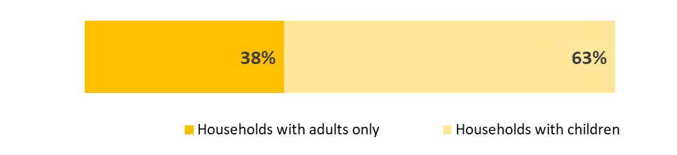
Figure 1. Percent of households with and without children
The average household size report by survey respondents is 3.7 but total the household size ranges from one person to more than 8 people. Sixty-three percent of respondents live with one or more children under 18. Thirty-eight percent of respondents live in adult-only households. Seventy-eight percent of households with children have two or more children living in them.
Figure 2. Percent of households with at or below the federal poverty level
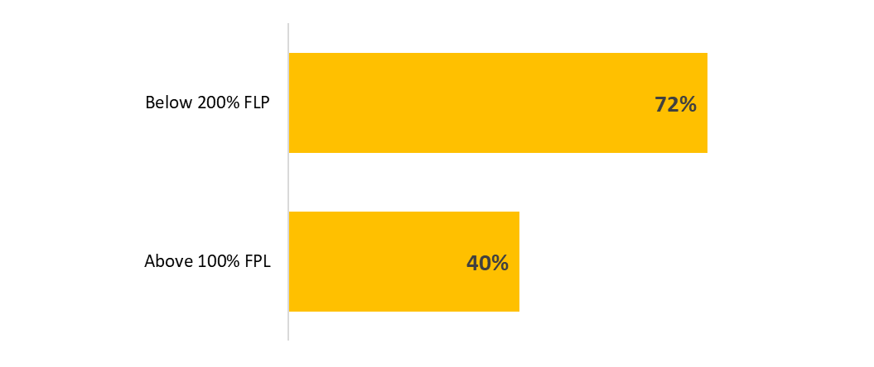
Seventy-two percent of respondents said they live in households with incomes at or below 200% of federal poverty level and 39 percent of respondents reported incomes at or below 100% of federal poverty level. However, 22 percent of respondents did not provide enough information to calculate poverty status. It is likely that a higher percent of respondents is living low income lives that reported. Poverty rates among survey respondents are similar by race and household type.

Employment
Figure 3. Percent of households with adults who work full time, part time, or are unemployed
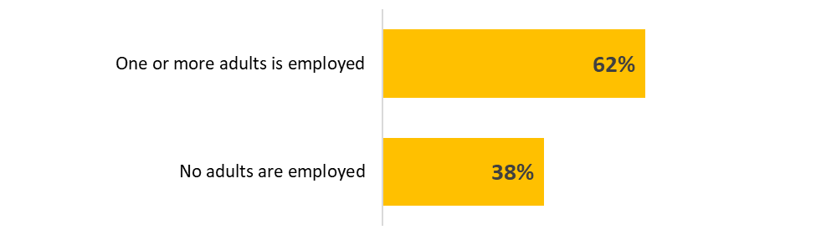
One or more adults has some type of employment in 62 percent of survey respondents’ households. This includes full or part time employment. In 38 percent of households, none of the adults are currently employed. In 41 percent of households one or more adults works full time and in 27 percent of households one or more adults work part time.

Employment barriers for the household
Figure 4. Reasons someone in the home is not employed
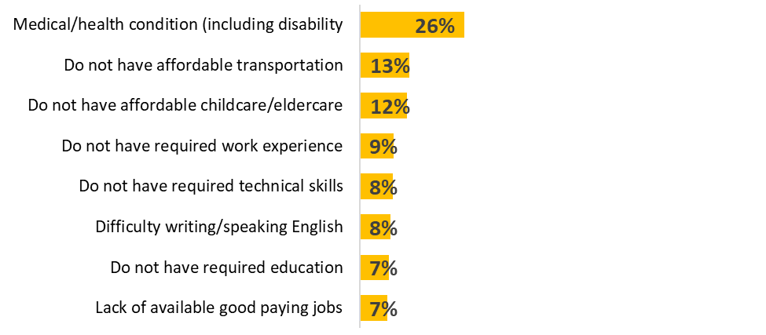
A medical or health condition, including disability, was the most common reason respondents said someone in their home is not employed (26 percent). Other reasons were do not have affordable transportation (13 percent), child or eldercare (12 percent), work experience (9 percent), English skills (7 percent), or the required education (7 percent). Lack of available, good paying jobs was also a barrier for 7 percent of households.

Employment barriers in the community
Respondents said the lack of good paying jobs that match the skills of people looking for work is a barrier to employment in the community. The lack of jobs for older workers and age discrimination are a barrier for older community members. Many people may lack the education, skills and training, or experience needed for the jobs that are available. New Americans face additional barriers to employment, including language skills, credentials and education that do not qualify them for work here, and having the correct paperwork to get a job.
Several respondents said structural inequities, racism, discrimination, and hiring practices that disqualify people with criminal backgrounds are significant structural barriers to employment in the community. Mental health, health concerns, and disabilities are also barriers to employment, either because the person cannot work or because they cannot find a job due to their condition.
Some respondents said low wages are a barrier to getting a job, because they cannot afford to pay for child care, transportation to work, or health insurance. Many respondents said caregiving for children or other family members makes it difficult for someone in their household or community to work outside the home, especially when their wages do not cover the cost of care. Others said the lack of transportation and transportation costs are a barrier.
With the cost of living so high, medical and dental very high, I have to weigh the pros and cons of working. If I work, then I may lose the medical and dental “I have through MNcare because of income limits. I would be worse off working than not working.” – Survey Respondent
“I’m disabled but I do try to stay busy. My body is my transportation however that isn’t always feasible. I’m in a lot of pain so I’m slow and I can’t always afford the bus or even a Lyft. I need help maybe figure out time management as a single parent and on a low budget with little resources. I would like access to grants, scholarship for the art and community volunteer work I do. Or any other training and support.” – Survey Respondent

Education
Figure 5. Highest education level of any household member
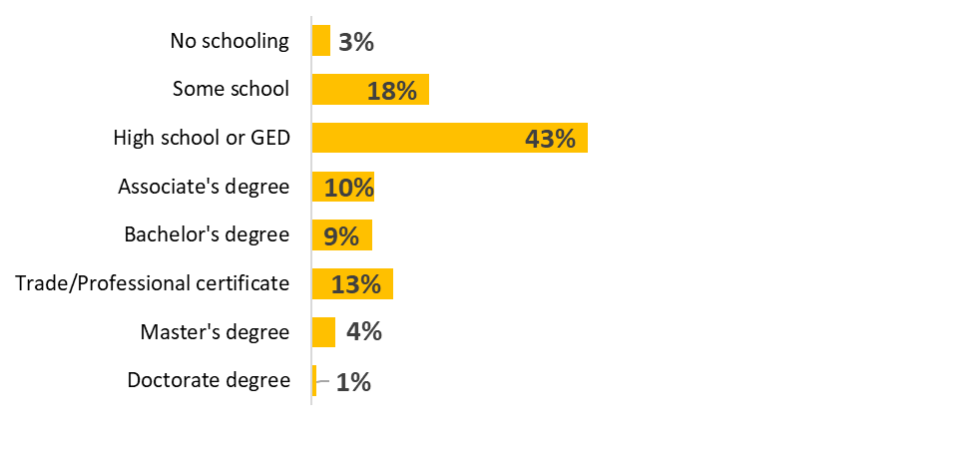
One in five of survey respondents said no one in their household has received a high school diploma (21 percent), and 3 percent said no one in their household has received any schooling. Forty-three percent of respondents said someone in their household has a high school diploma, 10 percent said someone had an associate degree, and 14 percent said someone in their household has a bachelor’s degree or higher. Thirteen percent said an adult in their household had a trade or professional certificate.
Educational attainment varies by race, with people who identify as Asian, black, or Hispanic/Latino reporting that no adult in their household has a high school diploma. This includes 42 percent of respondents who identify as Asian, 20 percent of respondents who identify as black, and 19 percent of respondents who identify as Hispanic/Latino.

Education barriers for the household
Figure 6. Households' education needs
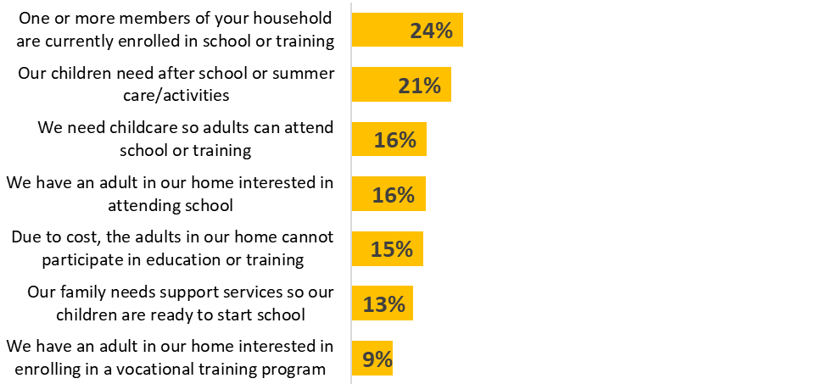
Twenty-four percent of respondents said an adult in their household is currently enrolled in school or a training program. Many respondents said least one adult in the household is interested in attending school (16 percent) or a vocational training program (9 percent). Fifteen percent of respondents said cost is a barrier to attending school or training. Twenty-three percent of respondents with children under 18 in the home said they need childcare so that an adult in their home can attend school or training.
Twenty-five percent of respondents with children under 18 in the home said they need supports for child care or their child’s education. Twenty-one percent of respondents (39 percent of respondents with children under 18) said they need after school or summer care for their children. Eighteen percent of respondents with children in the home – 25 percent with children under 5 – said they need support services so their children are ready to start school. Support services include early childhood education, English language learning, and other supports.

Education barriers in the community
Many respondents said that childcare was a barrier to education in the community. This includes access to childcare, the cost of childcare, and eligibility for childcare supports. Several respondents said it was difficult to attend school or training because of the cost of housing, food, transportation, and other costs of living. One person explained that it was difficult to go to school and meet their financial obligations at the same time.
A few respondents said structural inequities, including the achievement gap, are a barrier to education in the community. These respondents said there was a need for more teachers of color, more culturally appropriate education, college prep support, and English classes for people who do not speak the language.

Transportation
Figure 7. Transportation types by household
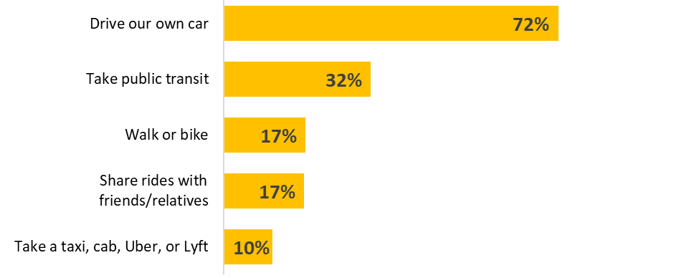
Nearly three quarters of respondents said they drive their own vehicle to get to the places they need to go (72 percent). One third said they take public transit, and 17 percent said they walk, bike, or share rides. Ten percent said they use a taxi or a ride sharing service to get where they need to go. While 66 percent of respondents only identified one type of transportation, a third of respondents use one or more different modes of transportation to get where they want to go, such as using their own car and taking public transit. However, 73 percent of people who drive their own car do not use any other type of transportation.

Transportation barriers for the household
Figure 8. Household barriers to transportation
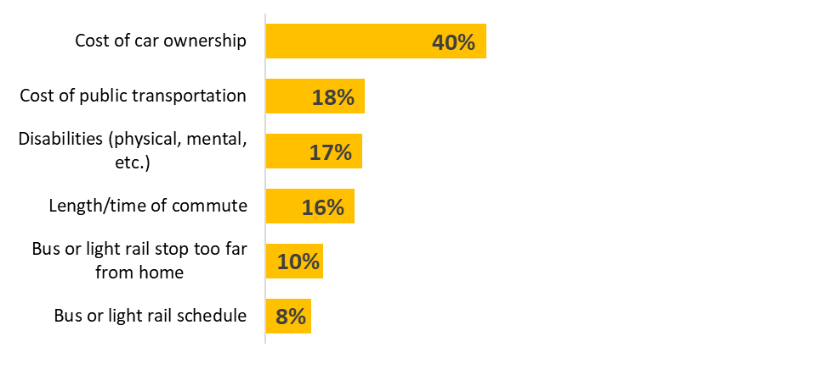
Transportation costs, including the cost of car ownership and the cost of public transportation, were the most frequently selected factors that make transportation difficult for respondents (40 and 18 percent, respectively). Seventeen percent of respondents said disabilities make transportation difficult, and about 40 percent of those respondents said they use public transit or their own car. Many respondents said scheduling and convenience factors, including commute time and distance, distance to transit stops, and transit schedules make transportation difficult (16, 10, and 8 percent, respectively.)
Transportation barriers are closely related to the types of transportation people use. For example, 78 percent of people who said the cost of car ownership is a barrier to transportation use their own car, which suggests that the cost of car ownership is a burden for more than half of people who own their car. In addition, 22 percent of people who said the cost of car ownership is a burden do not use their own car. Similarly, 78 percent of people who use public transit said cost and schedules are a barrier to transportation while 70 percent identified distance to transit stops.

Transportation barriers in the community
When asked what other barriers make transportation difficult in their community, respondents again named the cost of car ownership as the biggest barrier to transportation. Respondents said gas, car repairs, and car insurance expenses all make it difficult to get around. A few respondents added that some people drive without car insurance or drive unreliable vehicles because they cannot afford to do otherwise. Having a driver’s license is also a barrier, especially for people who do not speak English or who have concerns about their immigration status.
Public transportation many people said there are not bus stops close to their home or where they need to go, especially in Washington County. Limited transit schedules, safety, and the cost of fares are also barriers to using public transportation. Some respondents said public transit is difficult for people with disabilities or physical limitations. Language may also be a barrier to using public transportation.
“The cost of insurance- some families cannot afford paying for automobile insurance and they end up driving without it which it’s extremely dangerous. I have seen some parents doing that. Another struggle is being undocumented and drive without a driver’s license and without insurance. Life for many families in our community is a struggle.” – Survey respondent
“We live in Cottage Grove, so we need more transportation it's only one bus that comes that way, we need more buses or trains.” – Survey respondent

Housing
Figure 9. Current housing status

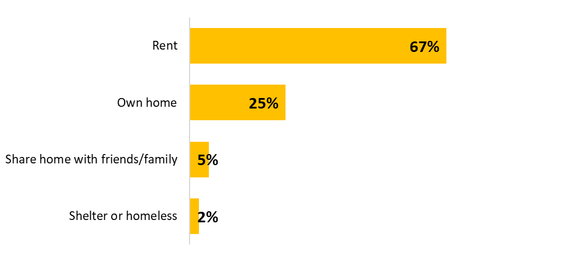
Two thirds of survey respondents rent their homes and one quarter own their homes (67 and 25 percent, respectively.) Seven percent either share their home with friends/family, live in a shelter, or are currently experiencing homelessness. Three-quarters of respondents who identify as black or and two-thirds of respondents who identify as Asian rent their home, compared to about half of respondents who identify as white.
Figure 10. Households experiencing housing cost burden
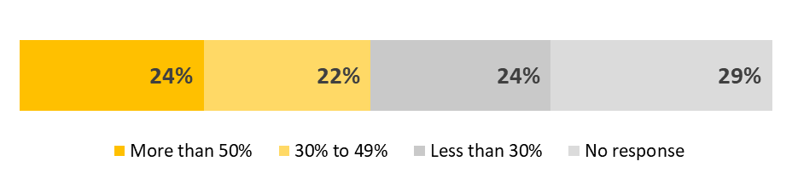
About half of survey respondents are currently considered housing cost burdened, which means they use 30 percent or more of their household income on housing costs. Twenty-four percent of respondents are considered severely housing cost burdened, which means they spend 50 percent or more of their income on housing costs. Renters and homeowners report being housing cost burdened at nearly identical rates. It is important to note that these results rely on self-reported income and housing costs and should be interpreted with caution. In addition, 29 percent of people either did not report housing costs or income. Regardless, these results do suggest that most people served by Community Action do not have enough income to keep up with housing costs.
Figure 11. Housing supports needed by the household
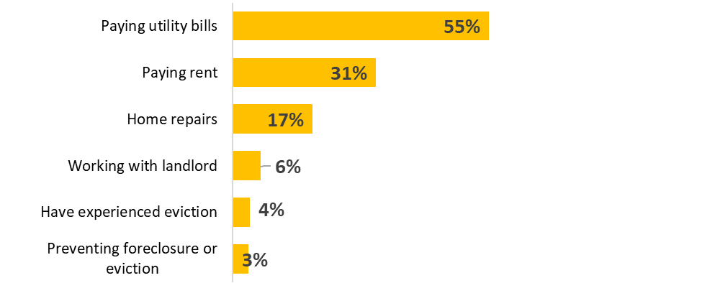
One third of respondents said they receive financial assistance for housing (32 percent). However, more than half of respondents said they need assistance with paying utility bills (55 percent), nearly one third said they need assistance paying rent, and 17 percent need assistance paying for home repairs. Some respondents said they need help working with their landlord and 4 percent said they have experienced an eviction in the past 12 months. Three percent said they need assistance to prevent foreclosure or eviction.

Housing barriers for the community
Lack of safe, affordable housing is the most common barrier to housing in the community named by survey respondents. When affordable housing is available, it is often in an unsafe neighborhood or poorly maintained. Several respondents added that they have problem with their landlords but are unable to move to safer housing because of cost or lease restrictions.

Health care
Figure 12. Health insurance status
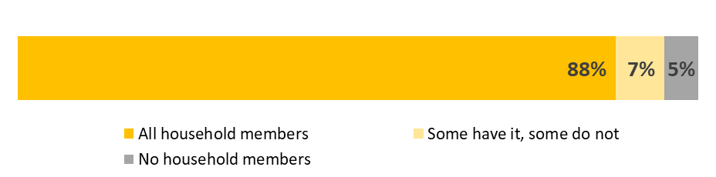
Most survey respondents said everyone in their household has health insurance (88 percent). However, in 12 percent of households at least one person does not have health insurance.
Figure 13. Health care use for the household
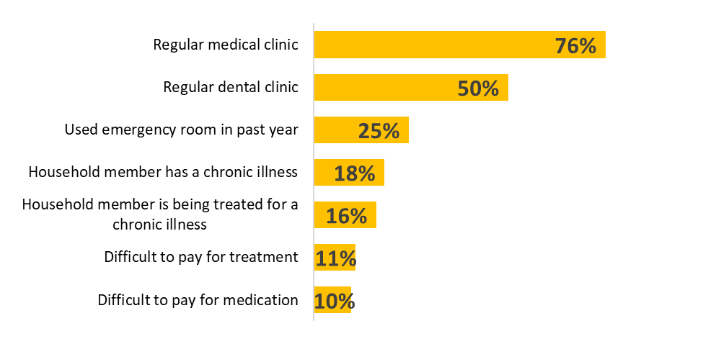
Seventy-six percent of respondents said they have a regular medical clinic and half said they have a regular dental clinic. Twenty-five percent said one or more members of their household used the emergency room in the past year. Eighteen percent respondents said a member of their household has a chronic illness and 16 percent said a household member is being treated for a chronic illness.
While most respondents said they have access to health care, paying for it is a concern for some. One in ten respondents said it is difficult to pay for treatment or medication (11 and 10 percent, respectively.)
Figure 14. Health insurance needs for the household
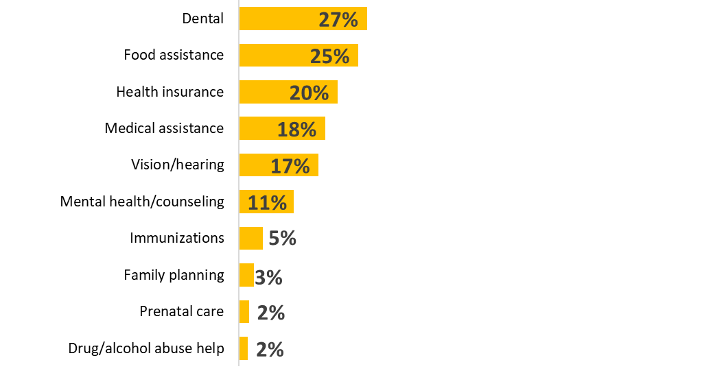One in four respondents said they need services to help with dental care and food assistance (27 and 25 percent, respectively). About one in five respondents said they need help with health insurance medical assistance and vision or hearing care (20, 18, and 17 percent, respectively) and 11 percent said they need services for mental health or counseling. Less than 5 percent of respondents said they need services to help with immunizations, family planning, prenatal care, or substance abuse supports.

Health care barriers in the community
Respondents said that health care costs, including the cost of care, prescriptions, and insurance are barriers to health. A few people said that access to transportation is a barrier to care.
“My husband has an artificial leg. We pay A LOT for new legs since he has to have insurance through his work vs MNcare like the rest of us. It is not "affordable" when we have to pay thousands and thousands every year for his leg. I wish he would qualify for MNcare too.” – Survey respondent

Nutrition needs
Figure 15. Nutrition needs for the household
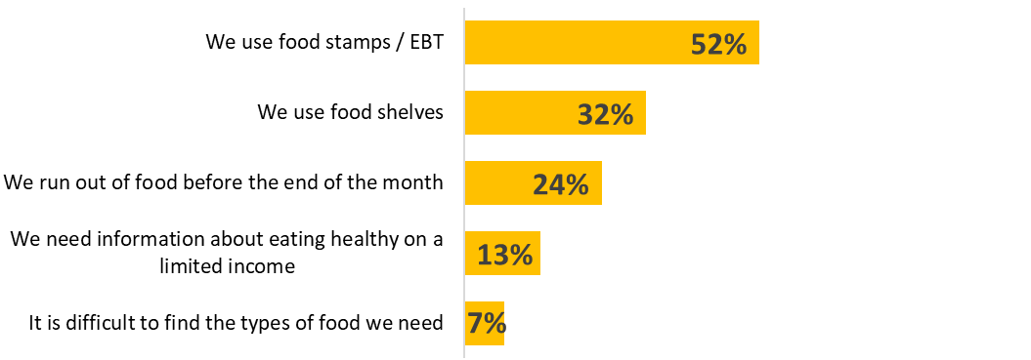
Over half of survey respondents use food stamps/EBT and a third use food shelves (52 and 32 percent, respectively.) One quarter of respondents said they frequently run out of food before the end of the month. Thirteen percent of respondents said they need information about eating healthy on limited income, and 7 percent said it is difficult to find the types of food they need.

Nutrition barriers in the community
Respondents said that the cost of food, access to education and classes that support healthy eating, access to healthy and culturally appropriate food, and knowing where to get affordable healthy food are barriers to healthy eating. In addition to food costs, other household expenses such as rent can be a barrier to healthy eating. Several respondents said that food supports such as SNAP benefits do not do an adequate job meeting their food needs because of low benefit amounts and low income thresholds. One respondent said Frogtown Farms is a valuable asset for increasing access to healthy food.
“I shouldn't have to worry about feeding my children when I work full time just because my rent is so high. I was homeless and barely qualified to move in to the apartment because my income was almost too low. You have to make under a certain amount to live here but they are allowed to raise the rent every year and in the middle of the lease.”– Survey respondent

Participant satisfaction
Figure 16. How respondents learned about Community Action
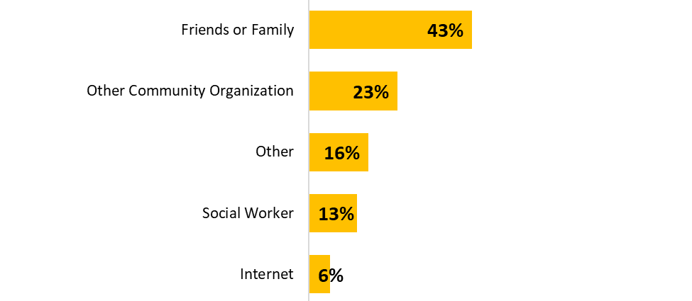
Forty-three percent of respondents heard about Community Action through friends and family, 23 percent were referred from another community organization, 13 percent were referred by a social worker, and 6 percent learned about Community Action through the internet. Sixteen percent heard about Community Action through another source, including fliers, through programs they were involved in, and other service providers.
Figure 17. Services received from Community Action
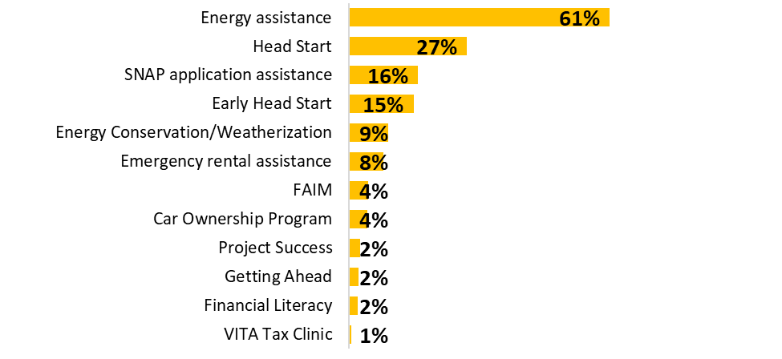
Of respondents who receive services from Community Action, 61 percent energy assistance services, 27percent participate in Head Start, 16 percent have received SNAP application assistance, and 15 percent participate in Early Head Start. Ninety-one percent of respondents receive two or more services from Community Action.
Figure 18. Participant satisfaction with Community Action services
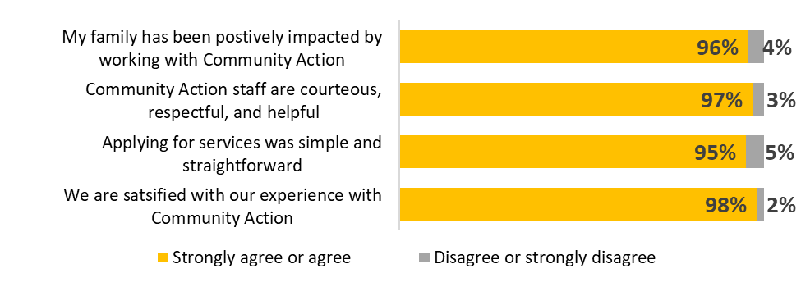
Nearly all of the respondents who receive services from Community Action agree or strongly agree that they are satisfied with their experiences with Community Action. Respondents said applying for services was simple and straightforward (95 percent), Community Action staff are courteous, respectful, and helpful (97 percent), and their family has been positively impacted by working with Community Action (96 percent.)

Appendix E: Participant Survey Protocol
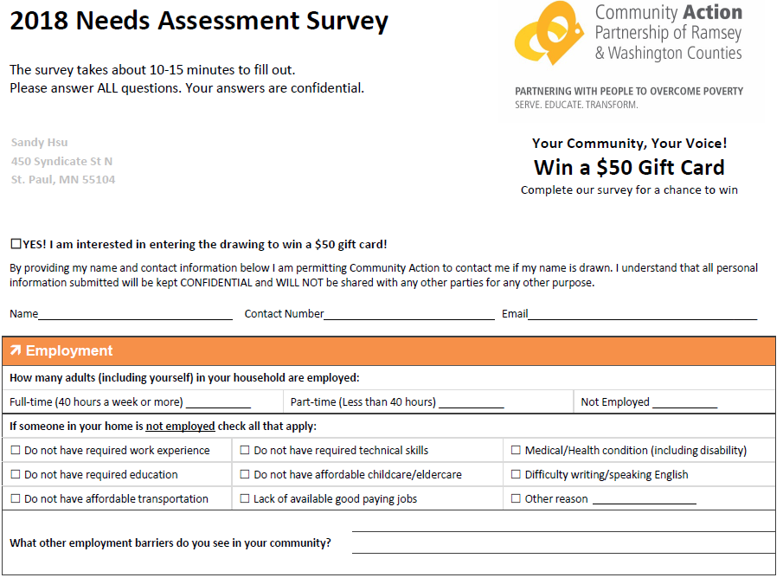
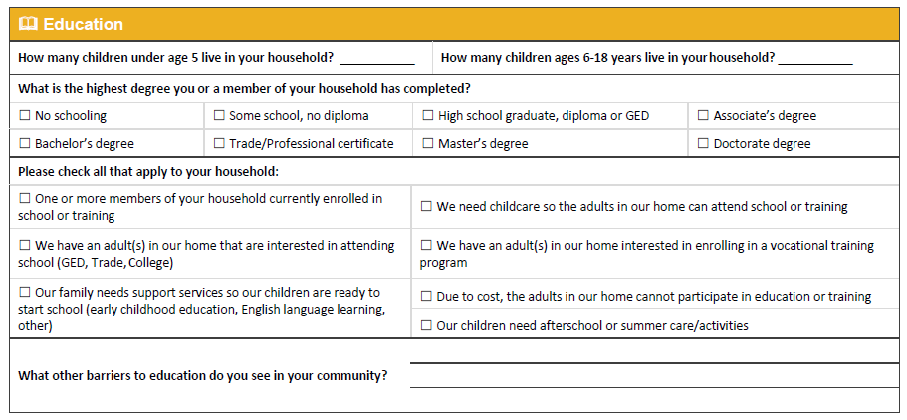
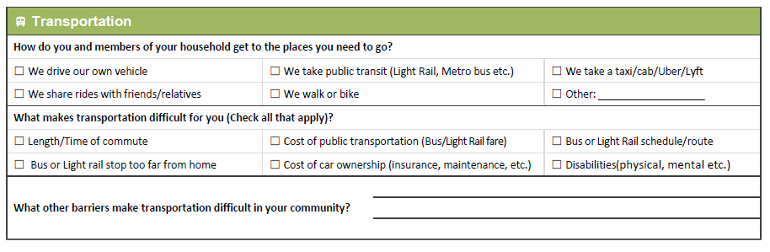
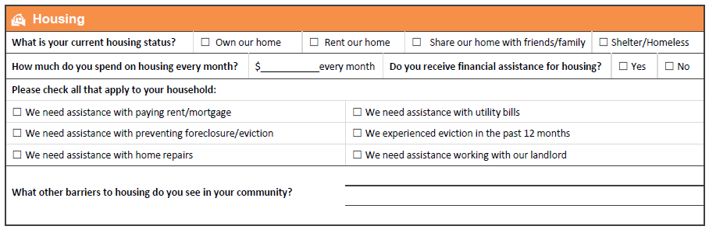
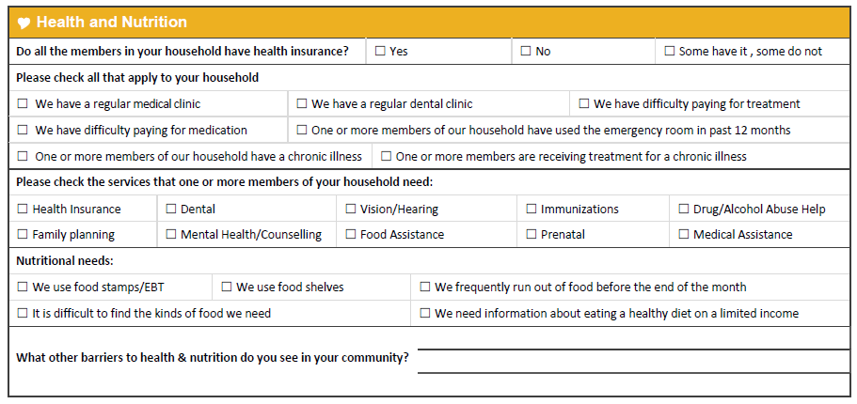
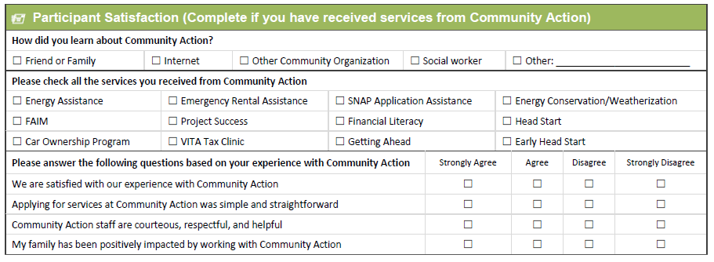
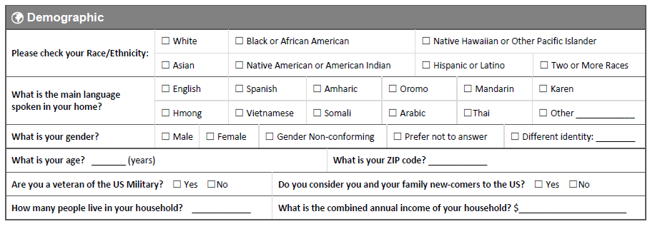

Appendix F: Solutions-focused Inventory Report

Introduction
This document outlines the emerging findings of the solutions focused inventory for Community Action Partnership of Ramsey and Washington Counties. The solutions focused inventory includes data collected during focus groups with Ramsey and Washington County residents who are currently living low-income lives. Community members were invited to participate because they self-identify as belonging to one of the key demographic groups identified in the community profile and trends analysis as having the greatest barriers to overcoming poverty.
At the final phase of this needs assessment, the analysis prioritizes community members’ reactions to the data so far, and their ideas for addressing poverty in Ramsey and Washington Counties.

Methodology
As of this summary, The Improve Group completed seven of the eight planned focus groups with community members who are currently experiencing poverty and live in Ramsey or Washington County. The remaining focus group is planned in late November. The focus groups were conducted from October 11 to November 9, 2018. The Improve Group recruited and paid Community Liaisons, (individuals who are either members of or have close ties to the selected communities) to lead culturally relevant focus groups and recruit community members for participation. The Improve Group trained Community Liaisons on how to conduct a focus group and recruit participants, provided them with templates for recruitment (e.g. flyers, social media posts, etc.) that they could adapt the language and messaging to be most relevant to the community being recruited, and provided Community Liaisons with technical assistance and support to throughout the focus group process.

List of focus groups:
Population | Location | Liaison
Limited opportunity/ability to increase income (e.g. elderly, people with a disability) | Ramsey County and Washington Counties | Vic Rosenthal, previously in leadership positions at several nonprofits in Ramsey County
Underemployed and unemployed | Washington County | Shereen Page, Community Action board member and Community Resource Coordinator at White Bear Area Emergency Food Shelf  (in planning stages; will be facilitated by The Improve Group)
Underemployed and unemployed | Ramsey County | Brenda Bolar, volunteer at The Salvation Army
Low income renters/unstably housed | Washington County | Shereen Page; facilitated by The Improve Group
Low income renters/unstably housed | St. Paul | Vic Rosenthal
Low income parents | St. Paul (primarily but not limited to) | Erin Pavlica, community member
Latinx (deportation and citizenship status) | Ramsey County | Cesar Orjuela, CLUES
Karen speakers (similar cultural and shared spoken language) | Ramsey County | Pae Say, Neighborhood House
The focus group protocol was designed to gather community member input and reactions to the data collected in the needs assessment to-date (community profile, participant survey, and trends analysis) and solicit community members’ solutions to addressing poverty and aiding people living low-income lives.
First, the participants reviewed the needs assessment results to-date in a brief, one-page report and the facilitator (Community Liaison or The Improve Group staff) led the group in a focused conversation. The results included the data gathered in the Community Profile (existing data), Trends Analysis (key informant interviews with partner organizations), and the Client Survey (Community Action’s 2018 client survey).
To solicit solutions, the facilitator asked participants questions including, “What are community strengths to leverage in addressing poverty?” and “What could Community Action do?” The facilitator wrote responses were written on large pieces of paper for everyone to see. After all possible solutions were written on the large pieces of paper, participants were given colored sticky dots. They were asked to put their dots next to the solutions they thought were best, they were most excited about, or think would have the most impact. The number of dots participants received varied between focus groups and depended on how many possible solutions the group came up with. This process of dot voting was used to encourage continued solution-focused discussion between participants and to gain a better understanding of the general ideas each focus group saw as important to creating solutions for the community. Because dot voting was used as a processing tool and not a true ranking system, all possible solutions groups created were used in the analysis.

Reactions to the information gathered in the Community Needs Assessment to-date

Focus group participants are concerned about access to affordable housing.

Focus group participants said they were not surprised that housing was identified as a challenge for the community.
Multiple community members at the focus groups agreed that a lack of quality, safe, and affordable housing is an unmet need in the Ramsey-Washington area.
They were not surprised that the number of households paying 30% or more of their incomes toward housing costs was rising and recognized this as an important issue for the community. Even when families in the community can find housing that is close to affordable, the quality of that housing is often very poor or unsafe. One group shared that landlords were a part of this problem, especially when they are unresponsive to problems around the property. Another focus group emphasized that housing costs prevent families from accessing other necessities, such as nutritious food. Community members at the focus groups also confirmed our finding that racial and systemic inequities can play a large role in housing challenges.

Focus group participants added that personal records with negative information in them are barriers to housing; they were surprised that this had not yet been made apparent in the needs assessment.
Community members at the focus groups said criminal history and background checks can be barriers to finding safe and affordable housing. They also noted that credit checks can prevent families from renting or owning properties, and that credit histories can be a large barrier even when a family can currently meet their financial obligations.

Affordable housing is a top concern among many focus group participants.
When asked what findings worried them, community members at the focus groups shared fears about rising rent prices and homelessness in the Twin Cities Metro. They worried that the cost of living would eclipse the wages they are able to earn or that they would be unwelcome in many neighborhoods. These fears are compounded by concerns about credit histories and background checks. Finding landlords that accept Section 8 and offer quality housing was also named as a worry for focus group participants.
One focus group discussed that a common goal among programs is to move people towards homeownership. Members of this focus group pointed out that not all renters want to or are able to be homeowners; renters need to be viewed as community assets and work is needed to stabilize low-income renters and make their rent affordable.

Focus group participants feel that their employment opportunities are limited.

Focus group participants agreed that there is a lack of well-paying jobs with opportunity for advancement in the community.
They expressed worry that even as the minimum wage increases, it will not keep pace with the cost of living. Community members at the focus groups shared that wages are often insufficient to meet their basic needs, even when working full-time. They also expressed frustration that many jobs did not offer opportunities for promotion or raises, describing how sometimes even managerial positions barely offer pay above minimum wage. Many people named a lack of opportunity to earn more as a major worry.
One focus group discussed that they have less resources when working full-time and not receiving any County or other benefits than when they worked less and did receive benefits. They said this is because even full-time jobs do not pay a living wage and County benefits completely stop when they earn just a few dollars per month too much to qualify for benefits.

Focus group participants also saw a lack of jobs that matched their skills.
Education was a barrier for participants in some groups, and they explained that although they have skills for certain jobs, employers won’t hire them because they lack higher degrees. Communities of recent immigrants also have a hard time finding jobs that match their skills. In the Karen focus group, participants described how members of their community had highly skilled and well-paying jobs, such as teaching and nursing, in their country of origin but were unable to find similar employment in the United States. This is a systemic problem, as many employers will not recognize previous education for this community.

Focus group participants were surprised not to see more information about barriers to employment included in the data previously collected.
Like barriers to housing, community members at the focus groups explained that credit and background checks can be major barriers to finding good jobs, especially for those who have been incarcerated.
One focus group discussed childcare as being a barrier to employment. They shared stories about trying to find friends and family to watch their children while they work because they cannot afford to pay for childcare, even though they are working.

A major source of concern for focus group participants were racial inequities in pay and hiring practices.
Community members at the focus groups described how people of color have more trouble finding jobs that their white peers. They were especially worried about pay gaps for people of color, describing how they often do the same exact work as white coworkers while receiving significantly less pay.

Barriers to healthcare and nutritious foods are concerns across focus groups.

Focus group participants described that even with food assistance programs such as SNAP and WIC, it can still be hard to afford nutritious foods.
Community members at the focus groups agreed that access to nutritious and culturally relevant foods is a challenge. They referenced both cost and access to stores as barriers to these foods. Nutrition was a greater need for families with children, especially because SNAP and WIC do not meet all nutrition needs. Families often need to supplement this type of assistance by going to food shelves. Focus group participants also shared that the income limits on these programs can make accessing them difficult, especially because at some incomes above the cut-off for SNAP, families are still unable to meet their nutrition needs.

Focus group participants agreed that access to healthcare is a challenge in the community
They agreed that costs were high and thought that although our findings exaggerated the difficulty of finding care, it is extremely difficult to understand systems and policies around healthcare, which is a large barrier to access. Furthermore, even when people receive healthcare through their employer it is so expensive that it is a financial burden on them. One focus group expressed the belief that increased access to healthcare is the community’s primary need. Community members in another focus group highlighted that finding quality, affordable dental care in the community is a challenge. This was such a challenge for one participant that it motivated her to begin college to enter the dental field.

Transportation was frequently referenced as a challenge by focus groups.

Participants in several focus groups struggled with the cost of transportation and agreed that access to transportation is an unmet need.
Community members at the focus groups shared that car ownership is a necessity because they were not always able to access adequate public transportation, especially when traveling in suburban areas. Some focus group participants explained that there are often more jobs available in the suburbs, but that they need a car to get there. The cost of owning and operating a vehicle can be a large barrier to these employment opportunities and other critical amenities and services. The length of travel with public transit between the city and the suburbs make this commute challenging, as do the transfers required and limited bus schedules. This was especially true for focus group participants from Washington County who must often rely on cars because there is not sufficient public transportation in the county.

Minnesota’s public transportation systems were something that gave Ramsey County focus group participants hope for their community.
Focus group participants who live in in Ramsey County appreciated that existing transportation systems are extensive and can be used to access much of the city. Although participants sometimes encountered cost barriers to these systems, focus groups suggested they could be improved to be more helpful. Focus group participants who live in Washington County felt significantly less hopeful about the role of public transportation in alleviating their transportation needs.

Education was named as a community need.

Focus group participants agreed that there are significant disparities and barriers to education.
Community members at the focus groups noted that education increases one’s access to better jobs, however, many struggled to access good education. Community members at focus groups saw education in technical job skills and in English language skills as the most important, although some participants also described traditional college degrees as needed. Focus group participants agreed that structural inequalities, transportation, childcare, and cost are all barriers to education. These structural inequalities were highlighted in one focus group where participants explained that there should be more supports for parents entering post-secondary education. They said this is because parents are juggling working, finding childcare, attending classes, doing homework, and transportation times.

Systemic inequities are major barriers in the community.

Focus group participants affirmed this needs assessment’s findings that racial and systemic barriers exist in many parts of life.
Community members at the focus groups referenced barriers in areas such as employment, housing, and education. They described inequitable access to earning and to education as frequent challenges. Some focus group participants made clear that these problems are a major cause of poverty for their communities. Policing and our criminal justice system, especially, are significant problems which enact and enforce systemic injustice.
One focus group expressed that it is obvious to them that systemic oppression is the root cause of poverty in the community. However, they said that people who are not living low-income lives do not recognize this. In fact, participants shared that they have been told they are “crazy” or “Get up. Get a job.” when they have tried to explain that the systems in place are oppressive.
Another focus group discussed that the needs assessment findings they reviewed seem to position the problems as the fault of individuals because they are living low-income lives or are people of color. They would like the needs assessment findings and solutions to be focused at a systemic level as opposed to an individual level. This group also discussed the need for equity in systems. One example they gave is that government and nonprofit services and programs are designed to find what disqualifies someone versus working to qualify people to participate in the program or receive services.

Focus group participants also saw discrimination and inequities based on gender, age, sexuality, and criminal background.
These were described as other significant points of systemic oppression or inequity in the community, and sometimes act as significant barriers to accessing housing, employment, and other necessities.

Government accountability was a source of hope for groups.

Focus group participants feel that Minnesota’s government cares about its people.
Community members at focus groups feel as though their input and lives are valued by their state and local governments. Several focus group participants had been involved in community meetings about policy and felt that these can be powerful tools, although they should be better advertised. This view was not shared among all focus group participants but was very strong among the groups who expressed it.

Focus group participants have faith that the government can and will be held accountable.
Community members at the focus groups are aware of means to contact and have input on government actions and agree that measures to hold the government accountable are important. These measures are not always accessible for all focus group participants, but their existence inspires hope.
In contrast, a couple of focus groups—where participants identified primarily as people of color—questioned the perspective that government accountability is a strength. While they said that local government accountability may be improving, community members of color continue to have distrust in government. These focus group participants have not seen the government invest resources in the community nor be held accountable for improving community viability.

Members of the community appreciated the chance to discuss these issues through focus groups.

Many community members at the focus groups used these focus groups to share their frustrations with the barriers they face.
In discussing barriers, focus group participants shared a lot of anger and frustration with their life circumstances. Not only are many of their needs unmet, they feel unheard by the people with the power to solve these problems. They shared that it was very powerful to see all the barriers they face on a daily basis listed on a piece of paper at the focus group. They were surprised and hopeful that an organization was acknowledging that all the barriers existed and were contributing to poverty in the community.

Focus group participants said that being at the table to talk about their community’s challenges and ways to solve them gave them hope.
Although the issues discussed are often long-standing in the community, community members at the focus groups are hopeful about finding solutions. Gathering to discuss ways to break these barriers helps them feel that they are not alone in these challenges and that there are people trying to solve them. Additionally, community members at focus groups explained that in the past they have experienced people and programs making decisions about what the community needs without asking anyone in the community for input. Community members appreciated that Community Action was asking the community about their needs through these focus groups.

Strengths to leverage

Community resources and connections were overall seen as a strength which can be leveraged.

Focus group participants see community members who are living low-income lives—such as themselves—as a major strength to be leveraged.
Community members at the focus groups explained that they themselves are a source of strength in the community. They shared that they hold experiences and deep community knowledge, which can be used to help transform the community toward ending poverty. However, in the past this strength has not been leveraged by organizations and they encouraged Community Action to do so. They want to be viewed as community assets instead of their current experience where they feel like they are labeled as victims.
One focus group encouraged Community Action to create a committee of community members to guide Community Action through the findings and help create next steps. They believe this would leverage community members and help Community Action to create the best solutions possible for the community.

Community connectedness and civic engagement are strengths.
Community members at the focus groups describe community unity as a major strength. Civic engagement, especially community meetings and volunteering, is an important tool which can be leveraged. Members of the community who were present at groups discussed the importance of community connectedness, knowing your neighbors, and supporting each other.

Focus group participants know about many useful community resources to use but cannot always access them.
Community members at the focus groups shared their knowledge of community resources and agreed that this was one of the community’s strengths. However, many focus group participants felt that there was not enough awareness about these resources, and that there could be better communication and coordination among organizations and service providers. Groups in Washington County also felt as though they had fewer resources than Ramsey County.
One focus group added that while there are several resources and programs in the community, there is a lack of access to mental health services and programs that promote seniors’ quality of life.

Diversity was identified as something which gave community members at focus groups hope.

Focus group participants said that diversity in their communities is a significant strength.
Diversity was repeatedly described as a strength in their communities, and as something which gives participants hope to see. Community members at the focus groups also talked about diversity in terms of the variety of personal experiences and skills within the community.

Messaging about poverty

Focus group participants want clear messaging to deconstruct stigma around poverty.

Focus group participants see stigma and myths around poverty as a serious problem and believe that Community Action can work to break these down.
Community members at the focus groups discussed myths around the causes and conditions of poverty as harmful to themselves as well as challenges in eliminating poverty. There is strong desire for more conversation that portrays the realities of poverty. Focus group participants emphasized that there is nothing shameful about living in poverty and that they have pride in themselves and their lives.
Focus group participants encouraged Community Action to create messaging for the community and policymakers around poverty and people living low-income lives. They said that the goal of these communications should be to change the larger community’s perspective on poverty. Specific messages they suggested include: “poverty is not a choice,” “there is no shame in being low-income,” and “living in poverty or living a low-income life is not a character flaw.”

The way we talk about poverty is important.
Participants in one focus group feel that people in general make poverty seem less severe than it actually is. In another focus group, community members discussed different ways to refer to people experiencing poverty and showing that different framings can resonate differently between groups.

Focus group participants suggest that removing barriers will solve challenges facing people living low income lives.

Focus group participants believe that spreading awareness around the barriers which people in poverty face can help eliminate them.
Community members at the focus groups feel that some members of the community are completely unaware of the barriers faced by people experiencing poverty. They believe that being vocal about problems can help get them addressed.

Barriers to communication between people living low-income lives and organizations which serve them must be addressed.
For communicating with the community, organizations need to meet people where they are - in terms of making communication as accessible as possible – especially given the significant barriers which people in poverty already face. Accessing information can be a challenge, so organizations must do more work to provide information in multiple languages, formats, use plain and simple language, and have information available in a variety of locations (e.g. not only on the organization’s website).

What it would look like if the community overcomes poverty

Focus group participants said that seeing less suffering in their communities will be proof of change toward ending poverty.

Community support for people experiencing poverty is an important sign of community change.
Focus group participants hope that the community will support people experiencing poverty. They described having a community which rallies around people who are suffering as proof of a changing environment. Community connections and assets would be improved, and those who do damage to the community, such as slumlords, would be held accountable. They envision a place where neighbors are helping each other, children are playing, and events like block parties are a common occurrence.

Focus group participants see their communities as being happier.
Seeing less suffering and extreme poverty will show that progress is being made. Several participants emphasized that having happiness in the community is the most important sign that progress is being made.

All people being able to afford their basic needs will prove that the community is changing.

Community members at focus groups say that the ability to access everything they need to have a safe, healthy life is the most important change.
Focus group participants suggested that earnings would be higher, unemployment would be lower, and they would no longer need to rely on food stamps or shelves. There would be more quality and affordable housing, people could access education and health care, and there would be more protection for community members.

What else Community Action of Ramsey and Washington Counties can do

Community Action can work to make policy changes in the community.

Focus group participants believe that policy and systems changes are essential to solving challenges in the community.
Community members at focus groups suggested that Community Action be present at political meetings, influence and support legislation, and assist community members in their desires to change policy. Removing language barriers for the community to connect to lawmakers is one way to do this. Focus group participants believe that Community Action should go beyond helping participants advocate for themselves and do more advocacy work as an Agency.

Community Action can work more closely with the community.

Focus group participants suggested that Community Action can help the community organize to make changes.
Community Action of Ramsey and Washington can do important work to connect people, information, and services—this is especially the case because the community already has many assets. Community members at the focus groups also suggested that Community Action be more present in the community to do this work, including showing up at community meetings.

Community Action can work to remove barriers for community members.
Focus group participants suggested that Community Action can work to remove barriers to accessing healthcare and resources, as well as educating the community on available services and policies. Coordination of services is essential in increasing access, as the time and effort it takes to access various resources is a large barrier to doing so.

Appendix G: Solutions-focused Inventory Community Focus Group Protocol and Handout

Introduction: 10 minutes
Thank you for participating in this focus group. I am [NAME] from [AFFILIATION]. What you share today will be used by Community Action Partnership of Ramsey and Washington Counties to plan for how they will serve the community in the next three years. With the help of The Improve Group, Community Action has already gathered information about the community’s needs by talking with community organizations, looking at public information on gaps in income and housing, and asking people to complete a survey.
At this point, we would like to dig a little deeper to find out what you see as the community’s needs and possible solutions. To do that, I am going to ask you to share your thoughts, feelings, and experiences in our community. I’m also going to ask you some questions on what CAP can do to best serve our community.
Your answers will be combined with answers from other focus groups, then we will do an analysis to determine themes and findings. These findings will be shared with Community Action, but they will not be given your individual responses. Focus group results will be given to Community Action this fall and they will plan for how to share this information with the community.
One thing that’s important to point out is when I say “community” today, I’m talking about Ramsey and Washington counties.
You were asked to participate in this focus group because we want to learn more from [INSERT POPULATON]. With that, let’s get to know each other. Please share your name and how long you’ve lived in the community.

Establish Ground Rules: 5 minutes
Thank you! As we begin, there are a few things to keep in mind:
- There are no right or wrong answers.
- Everyone’s ideas will be respected.
- Only one person talks at a time. I may ask someone who is talking a lot to give others a chance to talk and I may ask someone to talk who has been quiet.
- Please respect everyone’s privacy – do not share who was here or what was said today.
Any questions? I’m expecting this focus group to take between 60 and 90 minutes – does that work for everyone? We will be audio recording and taking notes on your conversation – is that okay with everyone?

Results So Far: 10 minutes
As I mentioned, we did some research to understand the qualities of people living in Ramsey and Washington counties – such as race, age, income, etc. – with a specific focus on people living low-income lives. The highlights of what we found are on the piece of paper in front of you. As I go through this, feel free to circle words or phrases that get your attention and jot down any thoughts and feelings you have, such as: What’s surprising? What’s missing? and Where do you feel hopeful? Then, we’ll discuss what you wrote down.
- Racial disparities – or unequal outcomes experienced by one or more racial groups – exist in household income, unemployment, education levels, and traffic stops
- The number of families paying 30% or more of their income on housing is rising in Ramsey and Washington Counties; renters are far more likely to be spending too much of their income on housing costs.
- Most families have access to a vehicle, yet costs of transportation are high.
- Access to health care presents a challenge for many Ramsey-Washington residents.
Next, we interviewed leaders and staff at nonprofits in Ramsey and Washington counties.
They said the main causes of poverty in the community are:
- Systemic oppression
- The gaps in wealth and income – unequal access to earning
- Changes in family or individual live (e.g. medical needs, separating from a partner)
Then, they said the unmet needs in the community are:
- Affordable, quality housing, including resources to support homeownership
- Access to transportation
- Access to well-paying jobs with opportunity for advancement
- Services need to be more responsive and better coordinated
- Stability is needed to get out of poverty
Those interviewed said community strengths or assets include diversity, government accountability, and community resources.
Clients who participated in Community Action’s survey said:
- There are not good paying jobs available that match their skills and oppression exists in the hiring system
- Barriers to education include childcare, transportation, and structural inequalities
- Public transportation does not meet everyone’s needs and owning a car is a significant cost
- There is a lack of quality, safe, and affordable housing in the community
- Most people have health insurance, but accessing healthcare is very expensive
- Barriers to health food include cost, access to healthy and culturally appropriate food, and a lack of classes to support healthy eating. SNAP does not do a good enough job of meeting nutrition needs.

Discussion on Experiences: 20 minutes

Questions
- What about the findings surprised you?
- What was not surprising?
- What in the findings worries you?
- Where do you feel hopeful?
- What should be done to address these issues?
- From your perspective, how does generational poverty – or coming from a family where past generations lived in poverty – impact families in the community?

Solutions: 30 minutes
Next, we’re going to talk about what Community Action can do. Community Action Partnership of Ramsey and Washington Counties is working to educate the public and influence policy on issues that affect people living low-income lives in our community. They do this by offering services and programs, but they’re mostly interested in getting your input on educating and influencing policymakers. Keeping that in mind:
- What community strengths could be used to support people living low-income lives?
- If you were to write messages for Community Action to share with people and policymakers, what should they say about poverty and people living low-income lives?
- What proof, or what differences in your life would you notice, that says the community is transforming to end poverty and help people get out of it?
  - Such as positive changes to policies, programs, partnerships, etc.
- What could CAP do to take action in our community? Keep in mind that CAP’s work focuses on educating the public and influencing policy.

Vote: 10 minutes
Now I’m going to give everyone three sticky dots. Look at all the ideas you came up with. Which ones on each page do you have the most energy around. Or, which ones are you most excited about or think are most important? Put one dot next to your top two on each page.
Which ideas have the most dots? Why?

Closing: 5 minutes
Thank you so much for your time today. Your insights are very important to Community Action as they plan for the coming years. Please make sure you get your gift card from me before you leave.

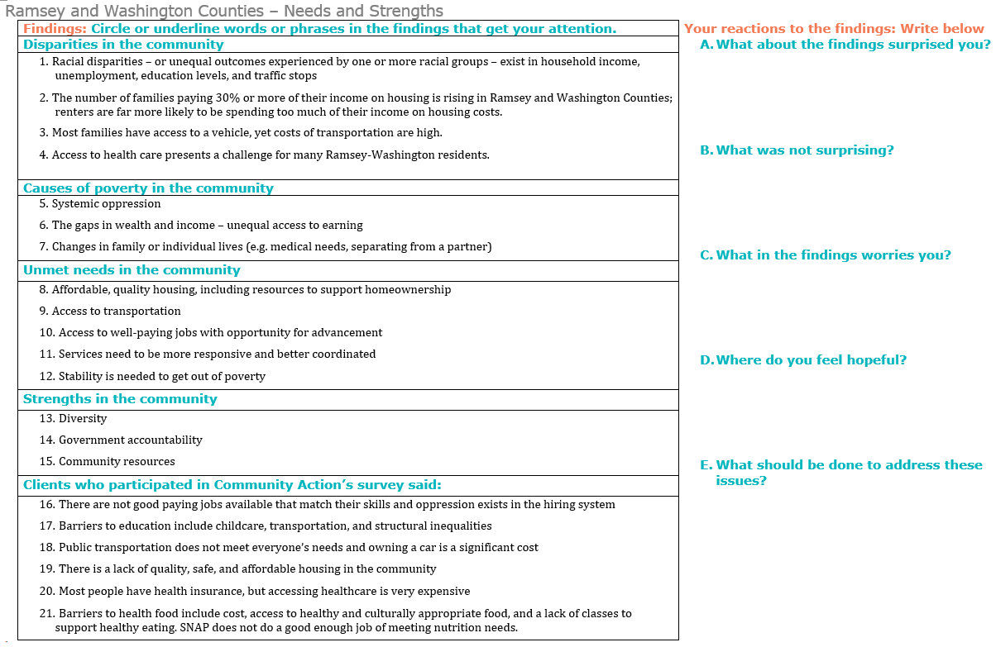

Defined by the Location Affordability Index as four-person households with two workers and income equivalent to the median for the geography.
U.S. Census Bureau. Decennial Census and American Community Survey 2012-2016 5-year data. Retrieved from http://factfinder.census.gov/
Vera. (2015). County trends. Retrieved from http://trends.vera.org/incarceration-rates
Minnesota Compass. (2016). County Profiles. Retrieved from https://www.mncompass.org/profiles
Minnesota Compass. (2016). Population Trends. Retrieved from http://www.mncompass.org/immigration/population-trends#1-5581-g
U.S. Census Bureau. Decennial Census and American Community Survey 2012-2016 5-year data. Retrieved from http://factfinder.census.gov/
Minnesota Compass. (2016). County Profiles. Retrieved from https://www.mncompass.org/profiles
Metropolitan Council. (2018). MetroStats. Retrieved from https://metrocouncil.org/Data-and-Maps/Publications-And-Resources/MetroStats/Census-and-Population/Income-Inequality-in-the-Twin-Cities-Region-Pa-(2).aspx
U.S. Census Bureau. Decennial Census and American Community Survey 2012-2016 5-year data. Retrieved from http://factfinder.census.gov/
Minnesota Housing Partnership. (2017). County Profiles. Retrieved from https://www.mhponline.org/publications/county-profiles/2016-county-profiles
Minnesota Compass. (2016). Disparities. Retrieved from http://www.mncompass.org/disparities/race#7-9426-g
U.S. Census Bureau. 2012-2016 American Community Survey 5-Year Estimates. Retrieved from http://factfinder.census.gov
Metro SHAPE 2014
U.S. Census Bureau. Decennial Census and American Community Survey 2012-2016 5-year data. Retrieved from http://factfinder.census.gov/
Child Care Aware. Cost of Care. Retrieved from https://www.childcareawaremn.org/community/cost-of-care/
Minnesota Compass. (2016). Early Childhood Risk and Reach. Retrieved from http://www.mncompass.org/early-childhood/risk-and-reach/overview
U.S. Census Bureau. Decennial Census and American Community Survey 2012-2016 5-year data. Retrieved from http://factfinder.census.gov/
U.S. Department of Health & Human Services. Office of the Assistant Secretary for Planning and Evaluation. Retrieved form: https://www.healthcare.gov/glossary/federal-poverty-level-fpl/
U.S. Census Bureau. Decennial Census and American Community Survey 2012-2016 5-year data. Retrieved from http://factfinder.census.gov/
Metropolitan Council. (2012). MetroStats. Retrieved from https://metrocouncil.org/getattachment/11eeda1c-d1d1-4cfd-8211-72455afc137c/.aspx
U.S. Census Bureau. Decennial Census and American Community Survey 2012-2016 5-year data. Retrieved from http://factfinder.census.gov/
Minnesota Compass. (2016). Disparities. Retrieved from http://www.mncompass.org/disparities/race#7-9426-g
U.S. Census Bureau. Decennial Census and American Community Survey 2012-2016 5-year data. Retrieved from http://factfinder.census.gov/
Minnesota Compass. (2016). Disparities. Retrieved from http://www.mncompass.org/disparities/race#7-9426-g
Minnesota Housing Partnership. (2017). County Profiles. Retrieved from https://www.mhponline.org/publications/county-profiles/2016-county-profiles
Minnesota Compass. (2016). County Profiles. Retrieved from https://www.mncompass.org/profiles
Minnesota Housing Partnership. (2017). County Profiles. Retrieved from https://www.mhponline.org/publications/county-profiles/2016-county-profiles
U.S. Census Bureau. Decennial Census and American Community Survey 2012-2016 5-year data. Retrieved from http://factfinder.census.gov/
U.S. Census Bureau. Decennial Census and American Community Survey 2012-2016 5-year data. Retrieved from http://factfinder.census.gov/
U.S. Census Bureau. Decennial Census and American Community Survey 2012-2016 5-year data. Retrieved from http://factfinder.census.gov/
Minnesota Department of Employment and Economic Development. (2017). Local Area Unemployment Statistics. Retrieved from https://apps.deed.state.mn.us/lmi/laus/
Minnesota Department of Employment and Economic Development. (2017). Local Area Unemployment Statistics. https://mn.gov/deed/data/current-econ-highlights/alternative-unemployment.jsp
Minnesota Compass. (2016). County Profiles. Retrieved from https://www.mncompass.org/profiles
Minnesota Department of Employment and Economic Development. (2017). Alternative Measures of Unemployment. Retrieved from https://mn.gov/deed/data/current-econ-highlights/alternative-unemployment.jsp
Minnesota Department of Employment and Economic Development. (2017). Job Vacancy Survey. Retrieved from https://mn.gov/deed/data/data-tools/job-vacancy/
Minnesota Department of Employment and Economic Development. (2017). Job Vacancy Survey. Retrieved from https://mn.gov/deed/data/data-tools/job-vacancy/
U.S. Census Bureau. 2012-2016 American Community Survey 5-Year Estimates. Retrieved from http://factfinder.census.gov
U.S. Census Bureau. 2012-2016 American Community Survey 5-Year Estimates. Retrieved from http://factfinder.census.gov
U.S. Census Bureau. 2012-2016 American Community Survey 5-Year Estimates. Retrieved from http://factfinder.census.gov
Minnesota Compass. (2016). Transportation. Retrieved from http://www.mncompass.org/transportation/overview
Metropolitan Council. (2010). Transportation Resources. https://metrocouncil.org/Publications-Resources-NEW.aspx
U.S. Census Bureau. Decennial Census and American Community Survey 2012-2016 5-year data. Retrieved from http://factfinder.census.gov/
Minnesota Compass. (2016). Transportation. Retrieved from http://www.mncompass.org/transportation/overview
Minnesota Compass. (2016). County Profiles. Retrieved from https://www.mncompass.org/profiles
Metro SHAPE Adult Survey. (2014).
Metro SHAPE Adult Survey. (2014).
Metro SHAPE Adult Survey. (2014).
Minnesota Compass. (2016). County Profiles. Retrieved from https://www.mncompass.org/profiles/
Saint Paul. (2017). Traffic Stop Dataset. Retrieved from https://information.stpaul.gov/Public-Safety/Traffic-Stop-Dataset/kkd6-vvns
Vera. (2015). County trends. Retrieved from http://trends.vera.org/incarceration-rates

